**VISVESVARAYA TECHNOLOGICAL UNIVERSITY**

**“JnanaSangama”, Belgaum -590014, Karnataka.**



**LAB REPORT**

**on**

**Big Data Analytics(23CS6PCBDA)**

***Submitted by***

**Abhishek Yadav (1BM22CS009)**

***in partial fulfillment for the award of the degree of***

**BACHELOR OF ENGINEERING**

***in***

**COMPUTER SCIENCE AND ENGINEERING**



**B.M.S. COLLEGE OF ENGINEERING**

**(Autonomous Institution under VTU)**

**BENGALURU-560019**

**Feb-2025 to June-2025**

**B. M. S. College of Engineering,**

**Bull Temple Road, Bangalore 560019**

(Affiliated To Visvesvaraya Technological University, Belgaum)

**Department of Computer Science and Engineering**



**CERTIFICATE**

This is to certify that the Lab work entitled “**Big Data Analytics(23CS6PCBDA)**” carried out by **Abhishek Yadav (1BM22CS009),** who is bonafide student of **B. M. S. College of Engineering.** It is in partial fulfillment for the award of **Bachelor of Engineering in Computer Science and Engineering** of the Visvesvaraya Technological University, Belgaum during the year 2024. The Lab report has been approved as it satisfies the academic requirements in respect of a **Big Data Analytics - (23CS6PCBDA)** work prescribed for the said degree.

Sarala D V **Dr. Kavitha Sooda**

Assistant Professor Professor and Head

Department of CSE Department of CSE

BMSCE, Bengaluru BMSCE, Bengaluru

`

**Index Sheet**

|  |  |  |
| --- | --- | --- |
| **Sl. No.** | **Experiment Title** | **Page No.** |
| 1 | MongoDB | 3-17 |
| 2 | MongoDB | - |
| 3 | Cassandra | 18-22 |
| 4 | Cassandra | 23-29 |
| 5 | Hadoop | 30-37 |
| 6 | Hadoop | 37-51 |
| 7 | Hadoop | 52-56 |
| 8 | Scala and Spark | 57-61 |

**Course Outcome**

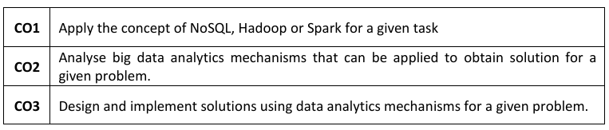

**Lab 1:** MongoDB- CRUD Demonstration

Question: Perform basic CRUD (Create, Read, Update, Delete) operations in MongoDB.

Code with Output:



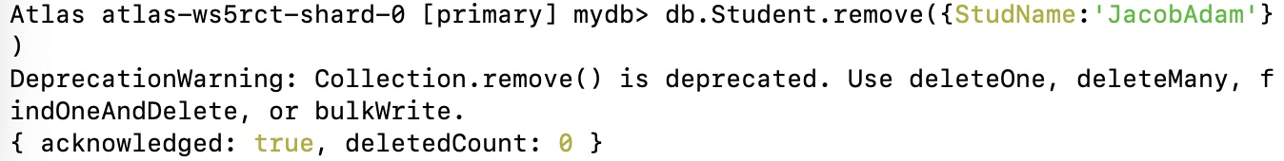

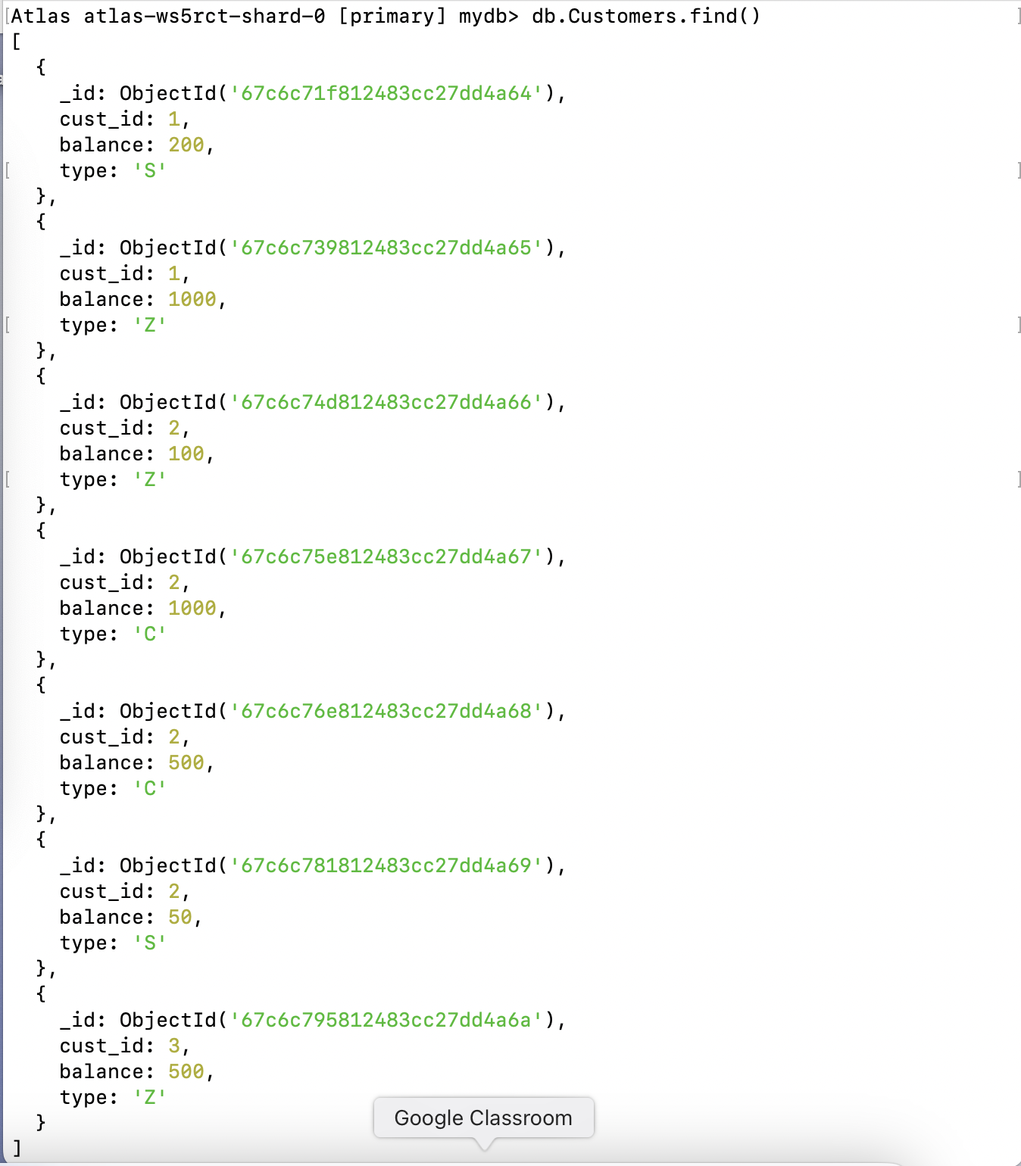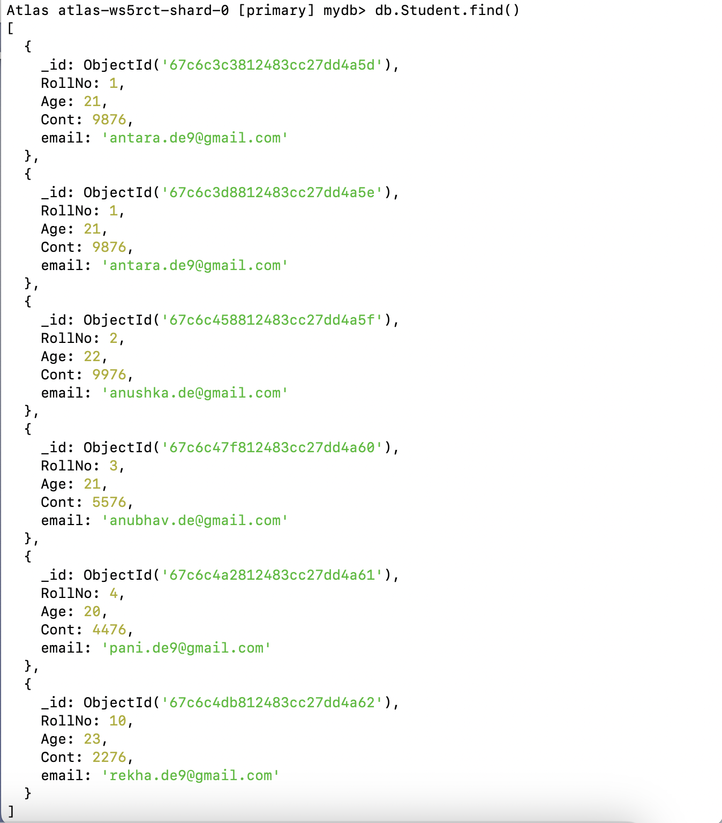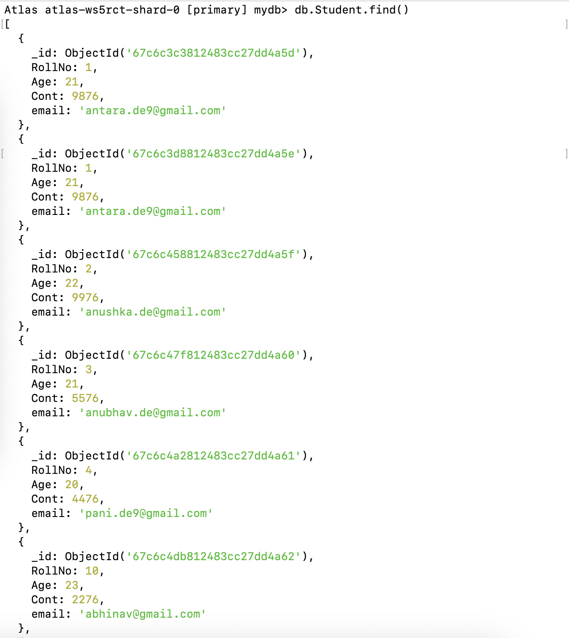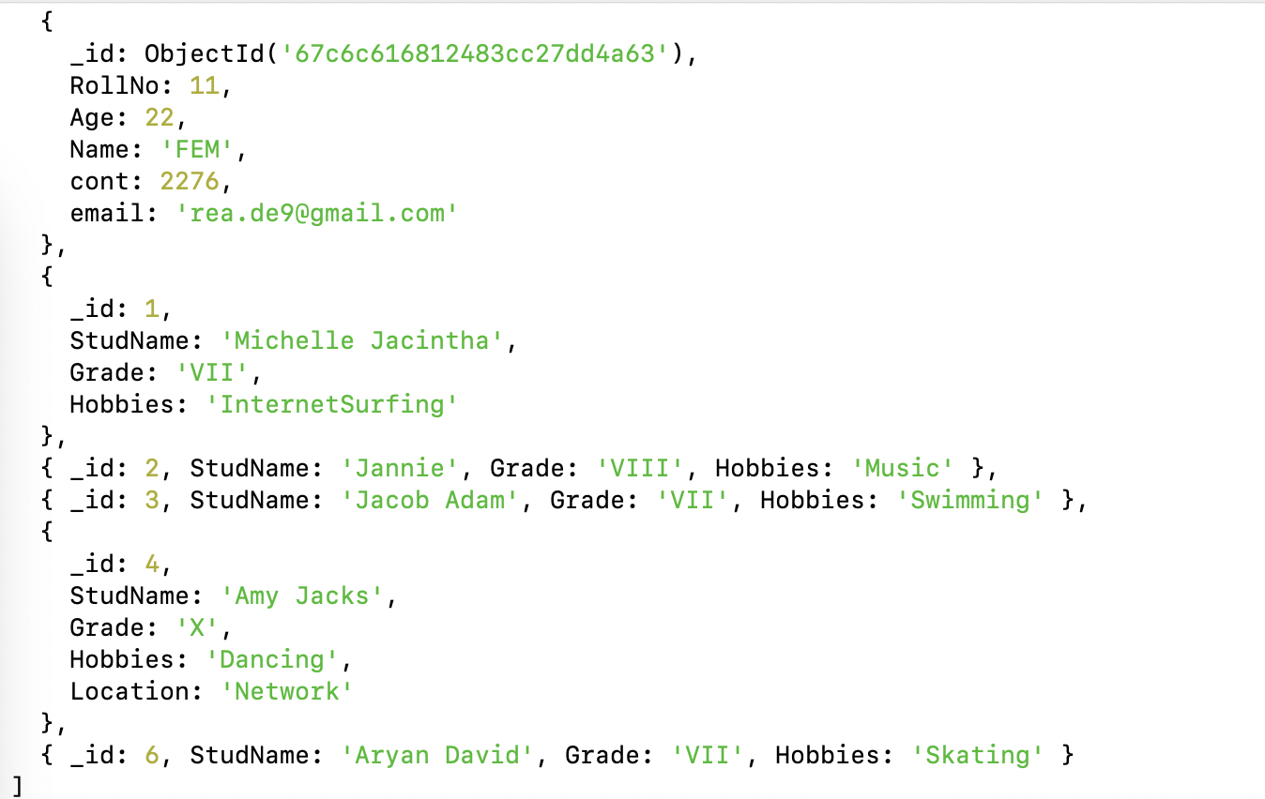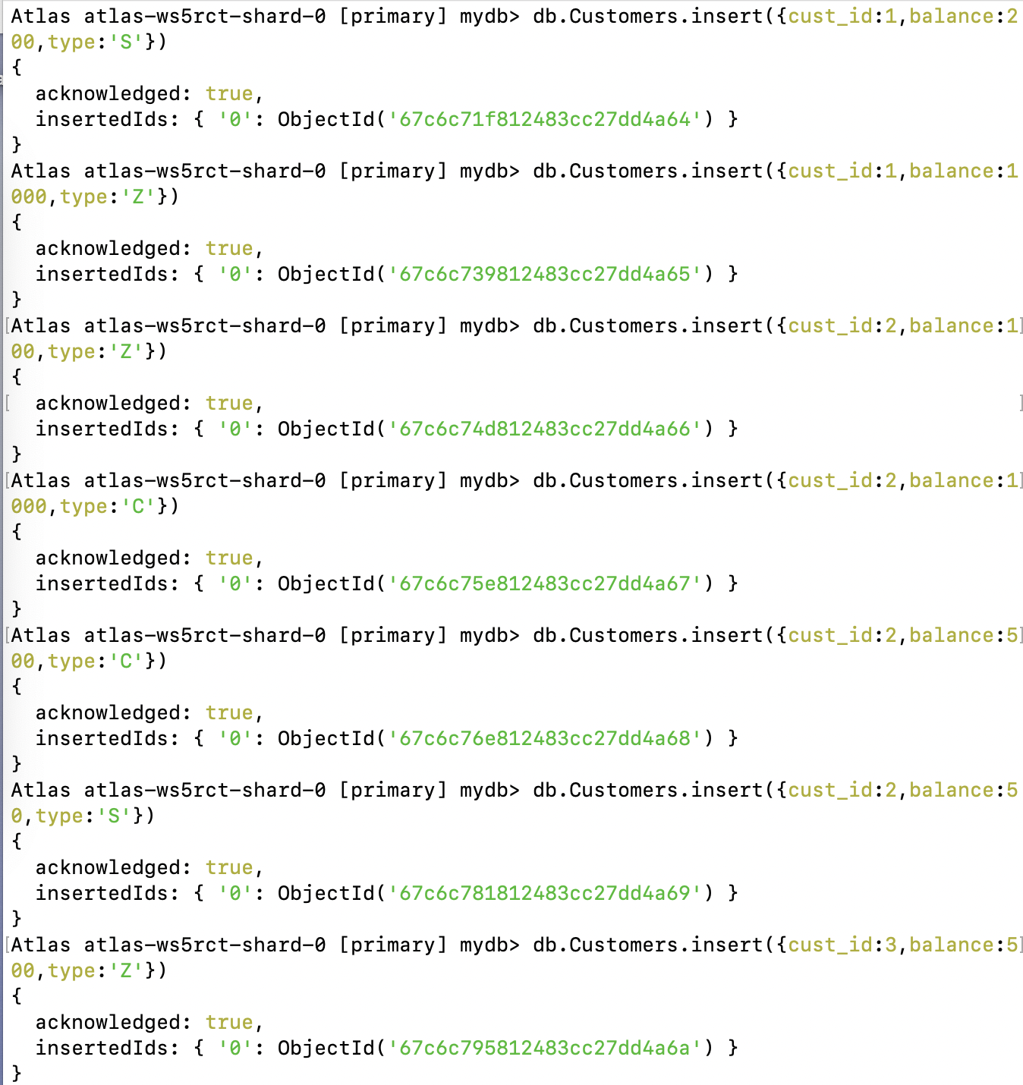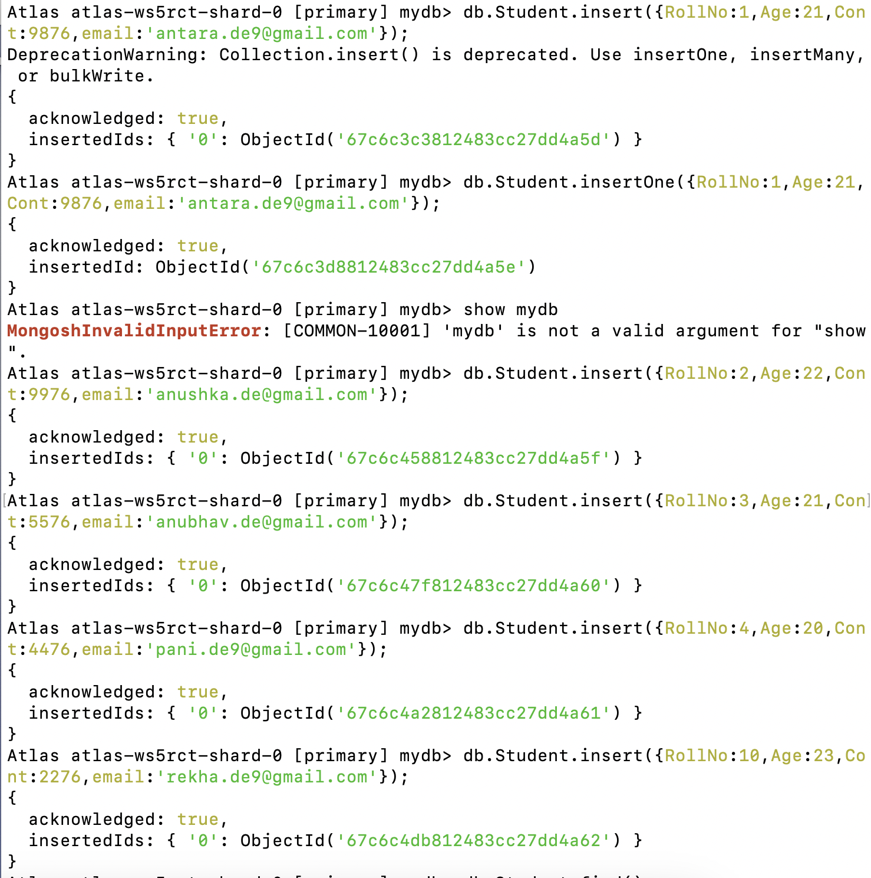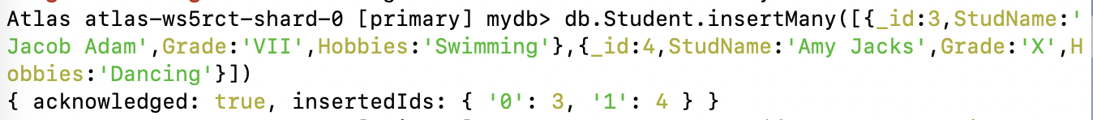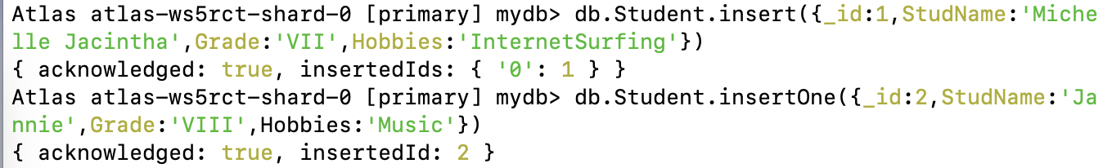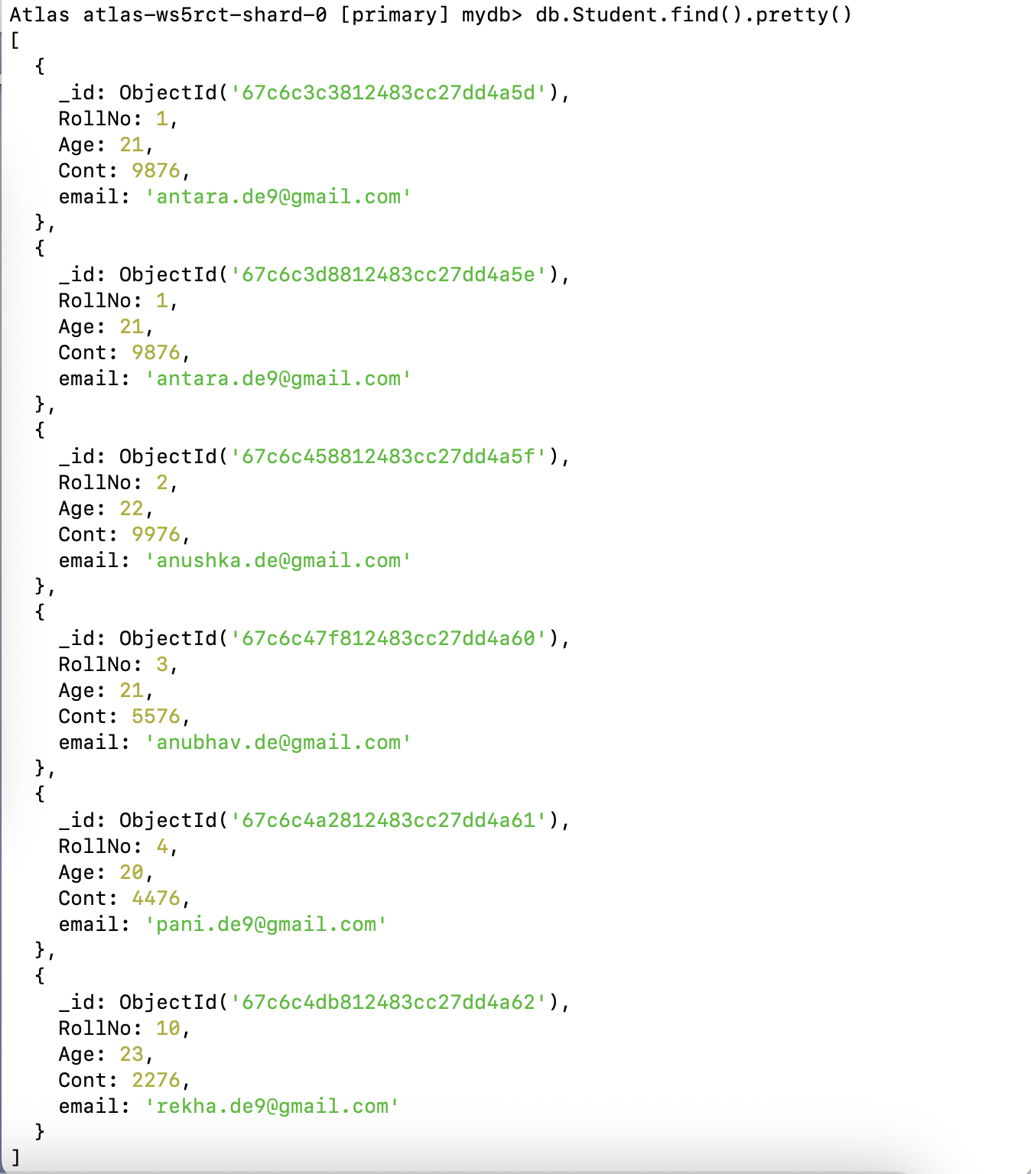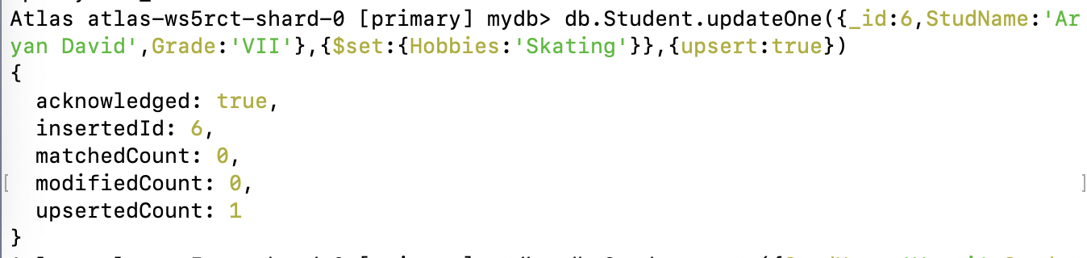

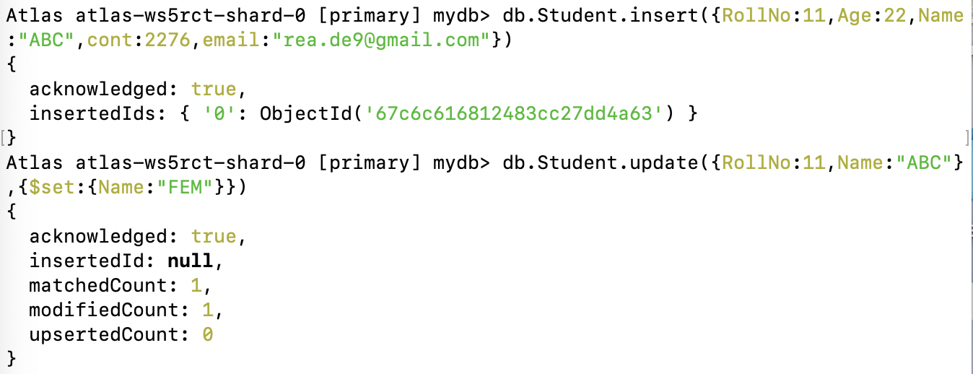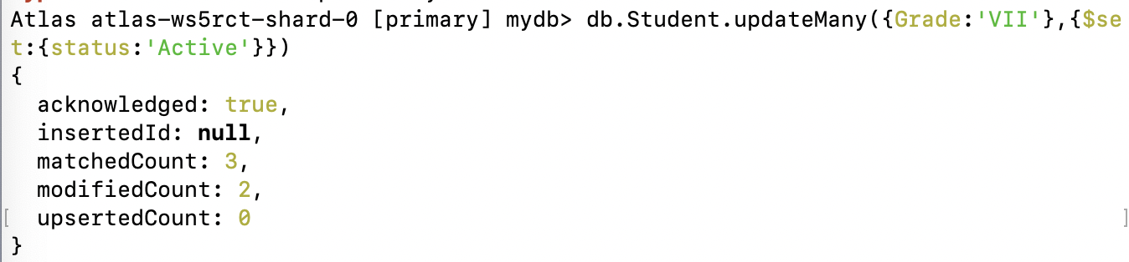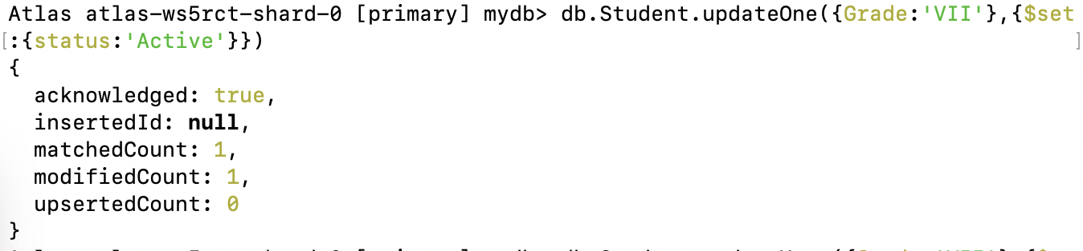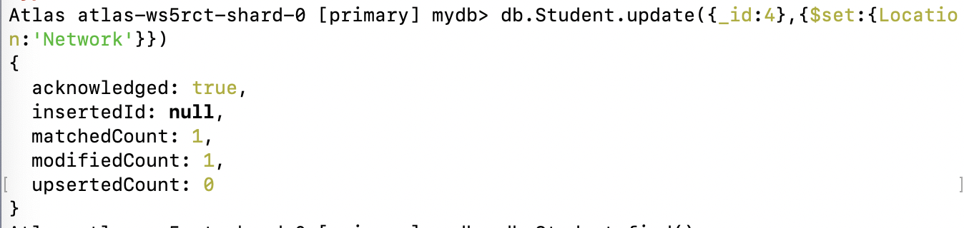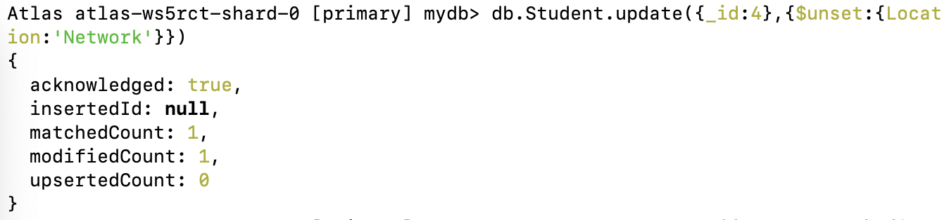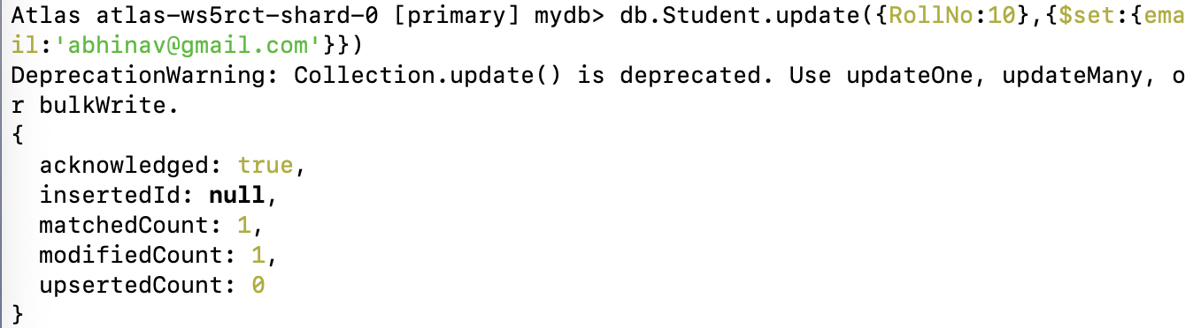

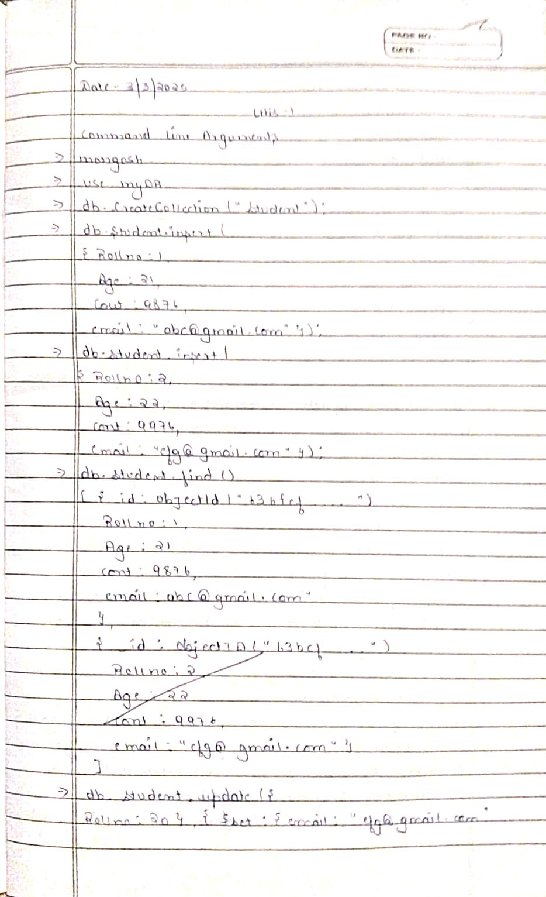

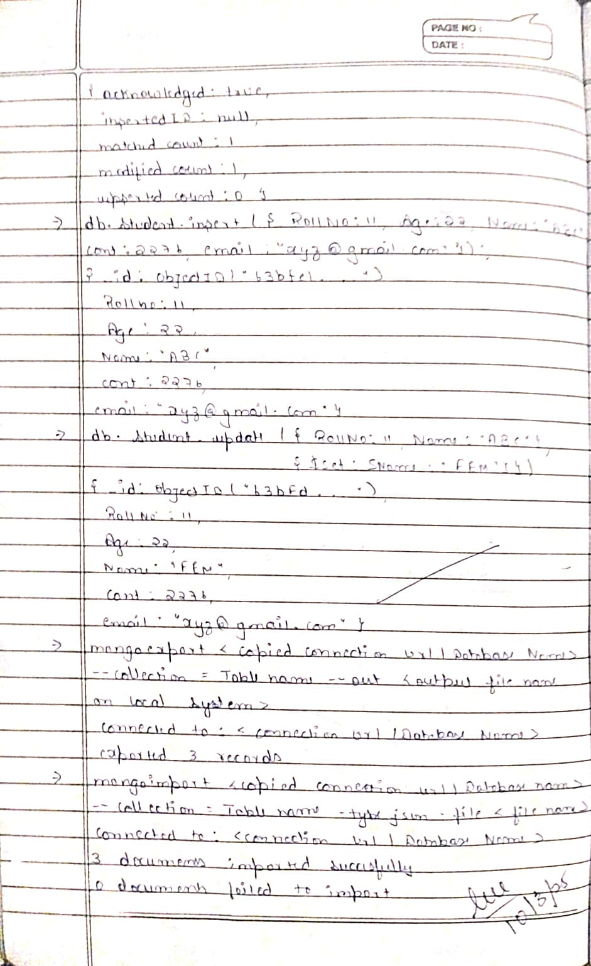

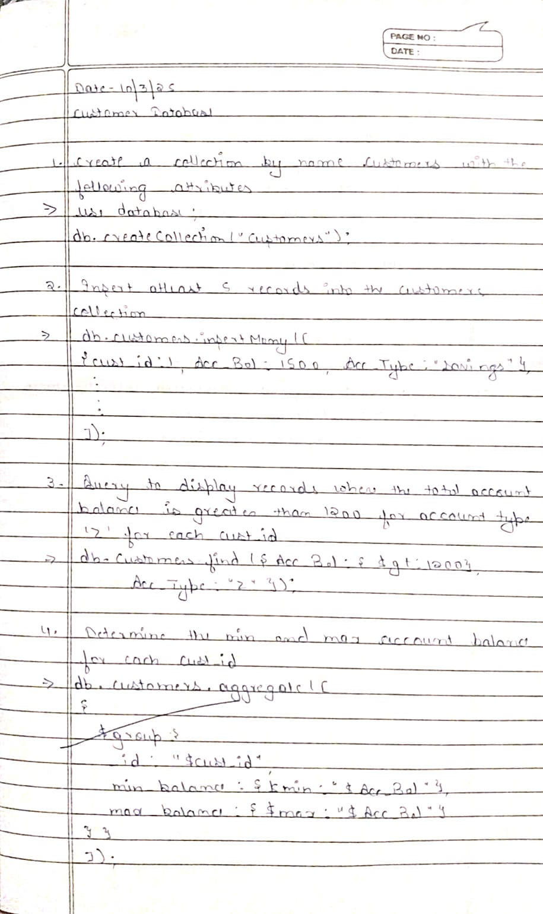

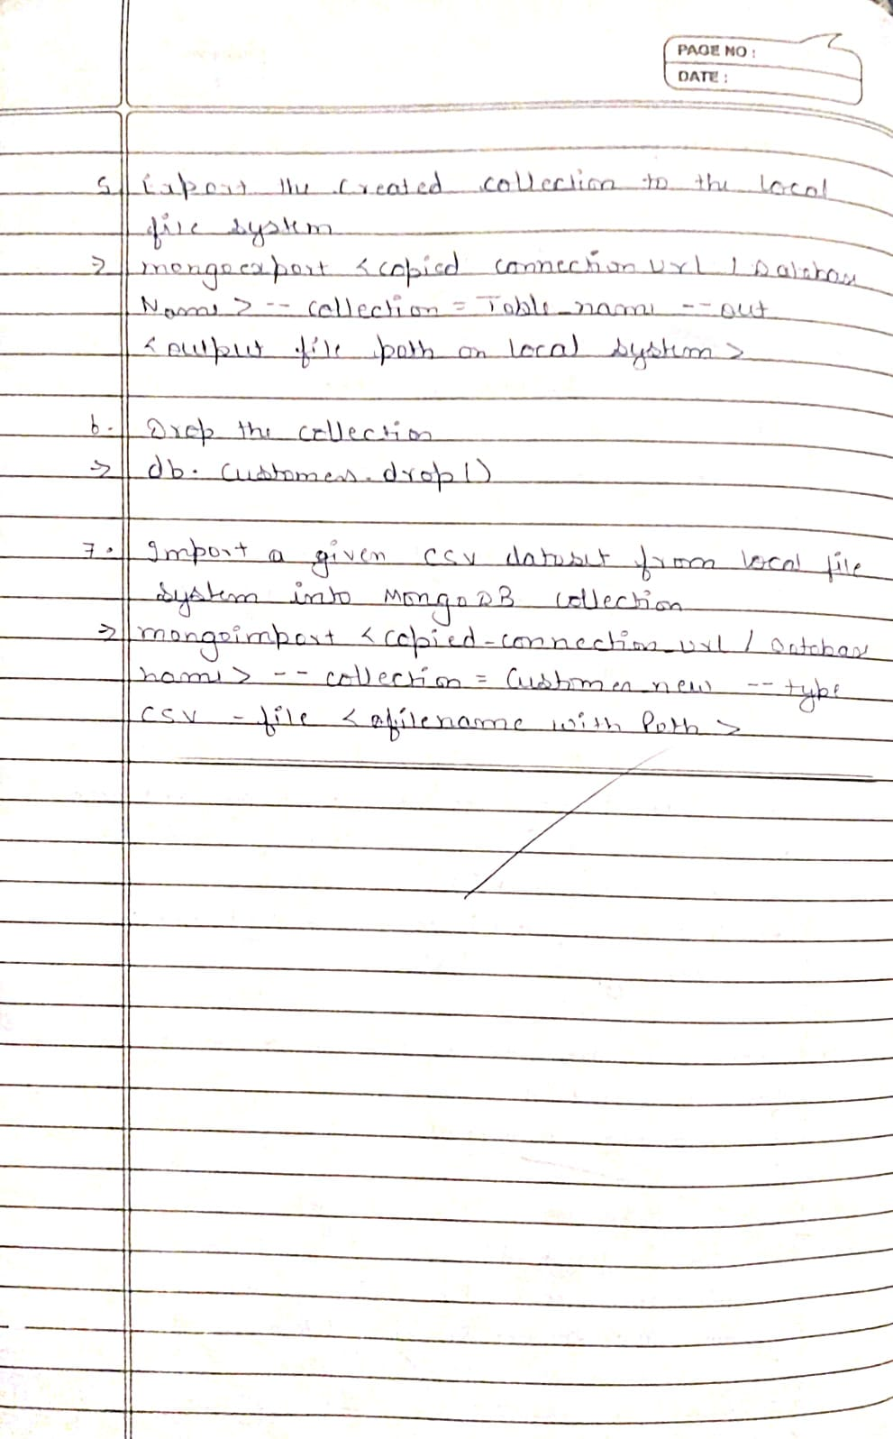

**Lab 2:** Cassandra

Question: Perform the following DB operations using Cassandra.

1. Create a keyspace by name Employee

2. Create a column family by name Employee-Info with attributes Emp_Id Primary Key, Emp_Name, Designation, Date_of_Joining, Salary, Dept_Name

3. Insert the values into the table in batch

4. Update Employee name and Department of Emp-Id 121

5. Sort the details of Employee records based on salary

6. Alter the schema of the table Employee_Info to add a column Projects which stores a set of Projects done by the corresponding Employee.

7. Update the altered table to add project names.

8. Create a TTL of 15 seconds to display the values of Employees.

Code with Output:

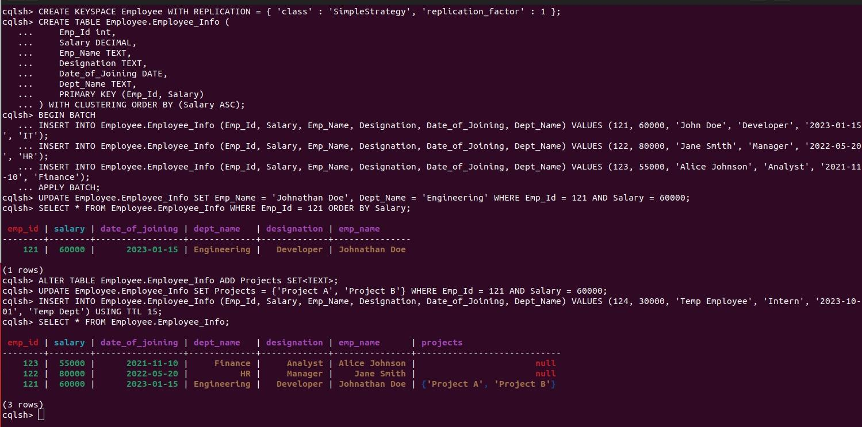

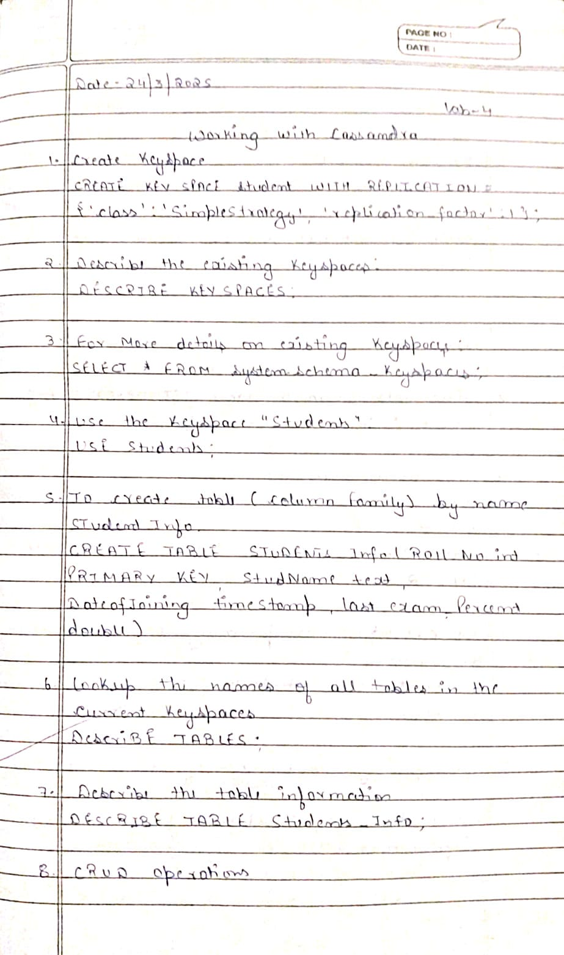

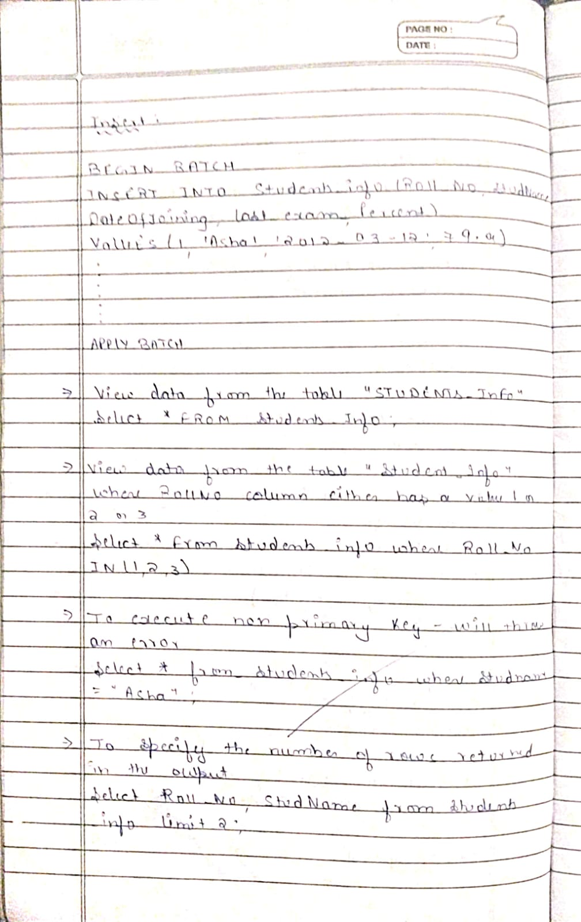

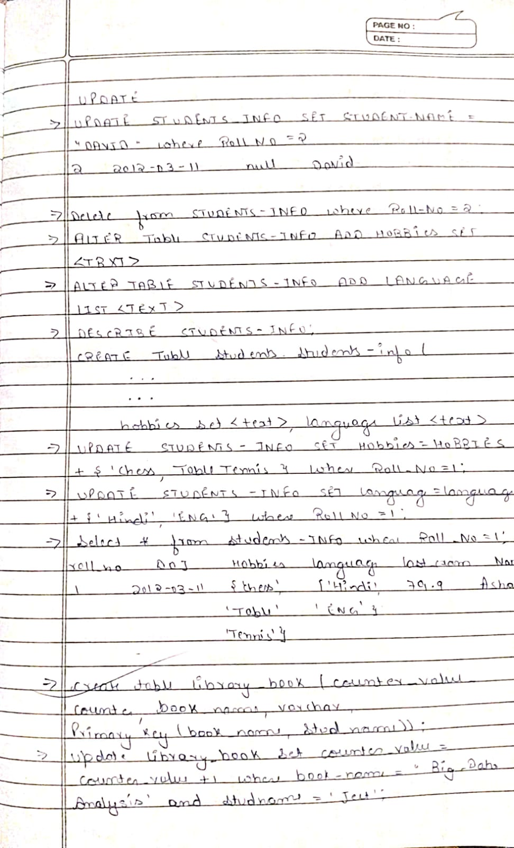

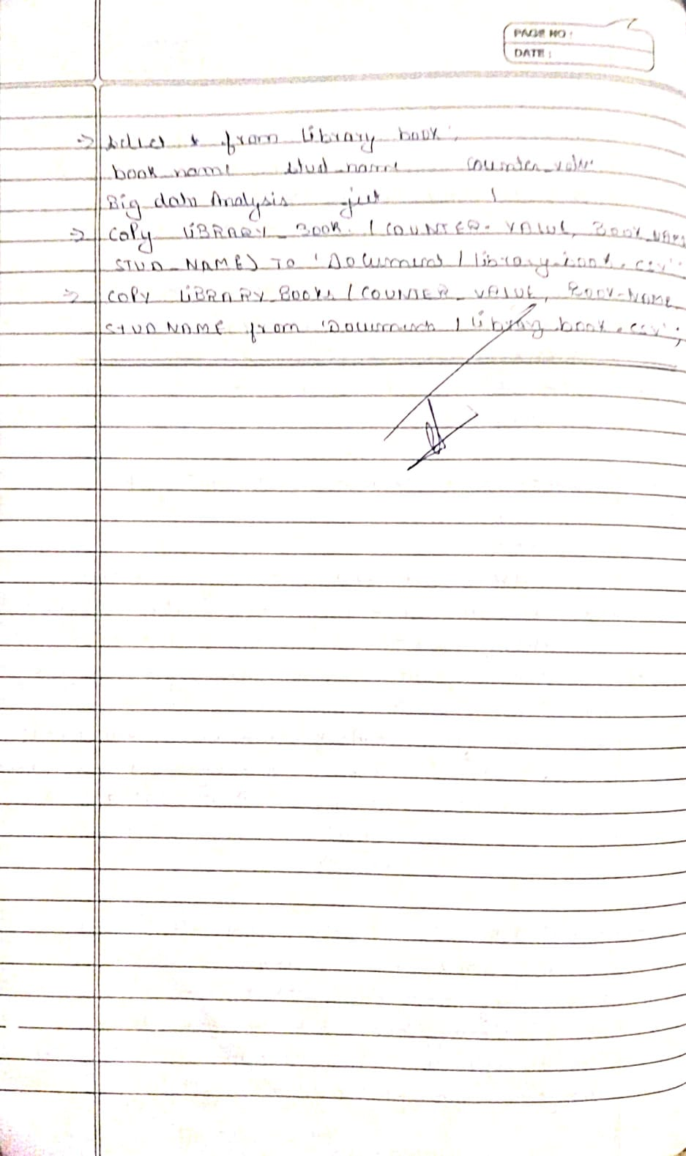

**Lab 3:** Cassandra

Question: Perform the following DB operations using Cassandra.

1. Create a keyspace by name Library

2. Create a column family by name Library-Info with attributes Stud_Id Primary Key, Counter_value of type Counter, Stud_Name, Book-Name, Book-Id, Date_of_issue

3. Insert the values into the table in batch

4. Display the details of the table created and increase the value of the counter

5. Write a query to show that a student with id 112 has taken a book “BDA” 2 times.

6. Export the created column to a csv file

7.Import a given csv dataset from local file system into Cassandra column family

Code with Output:

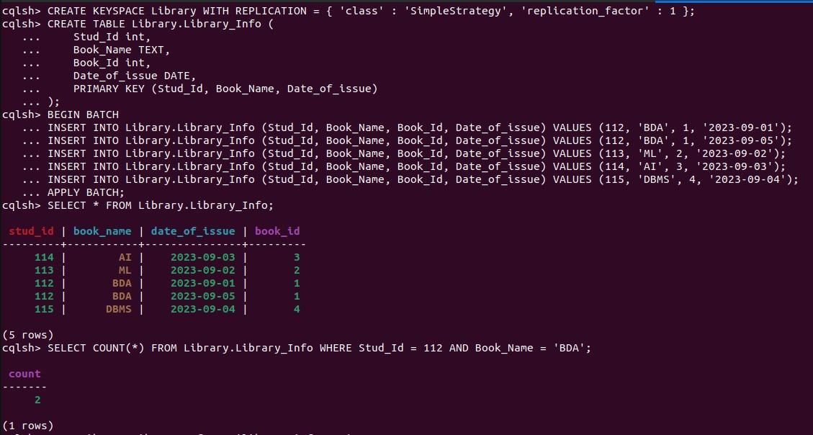

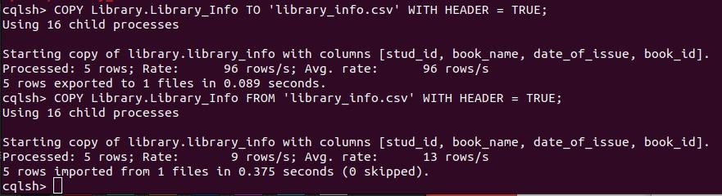

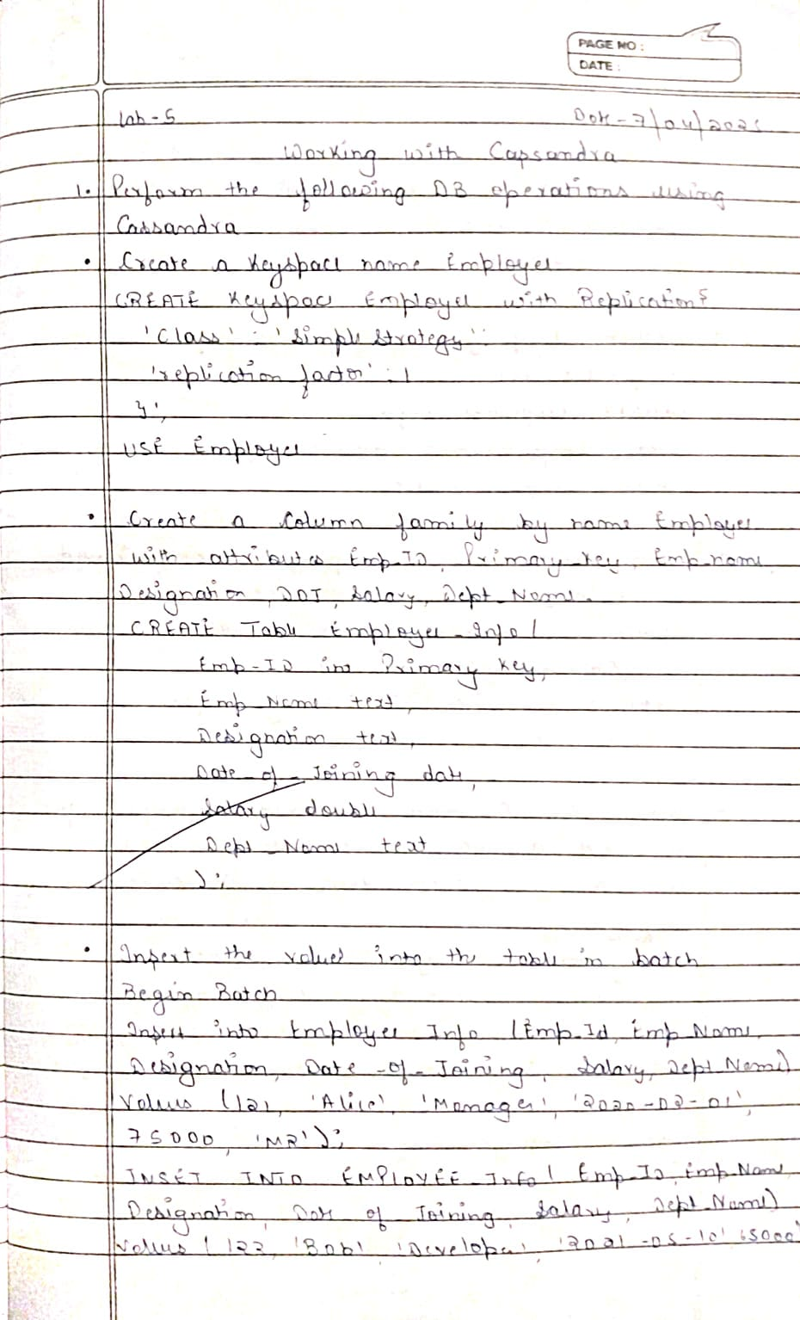

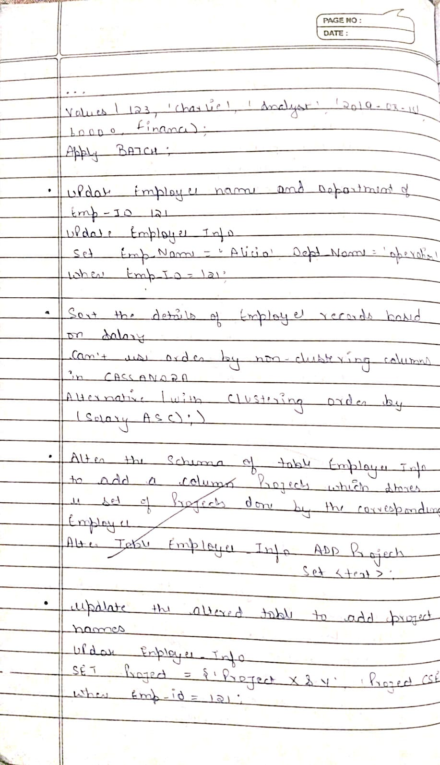

**Lab 4:** Cassandra

Question: Execution of HDFS Commands for interaction with Hadoop Environment. (Minimum 10 commands to be executed).

Code with Output:

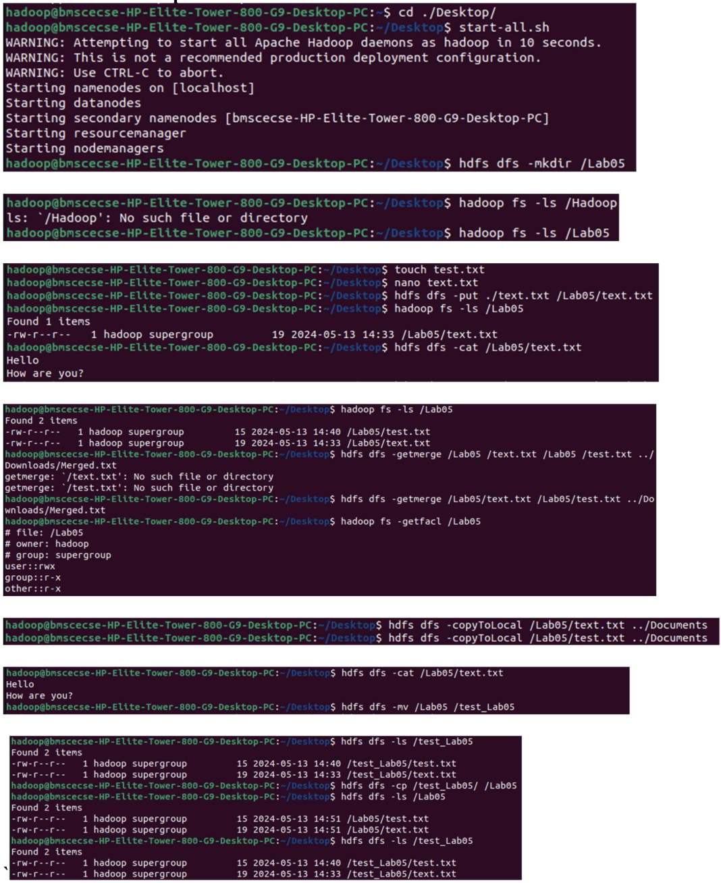

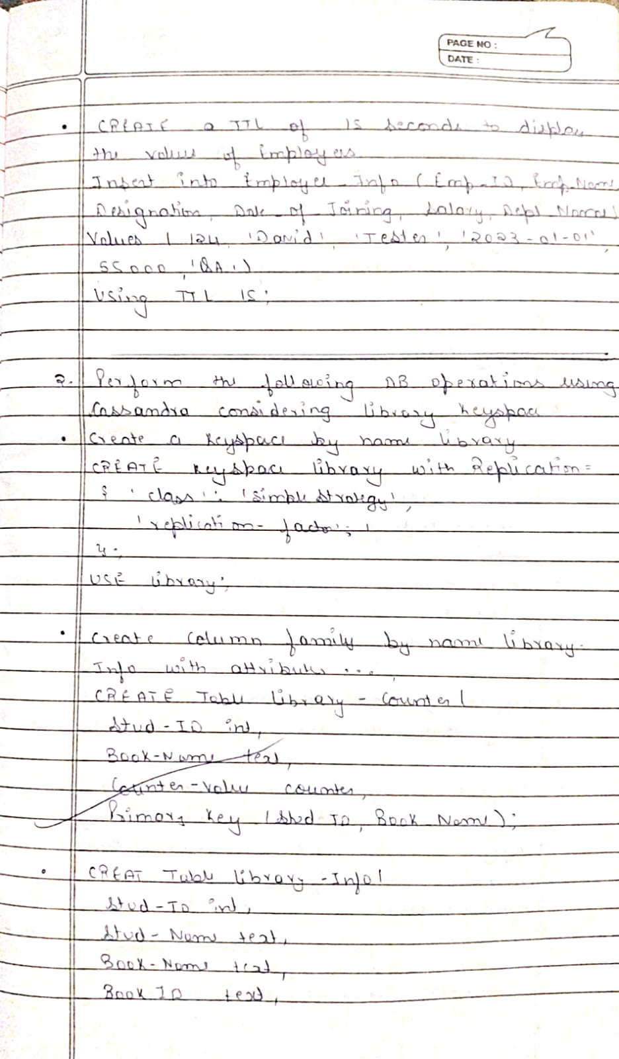

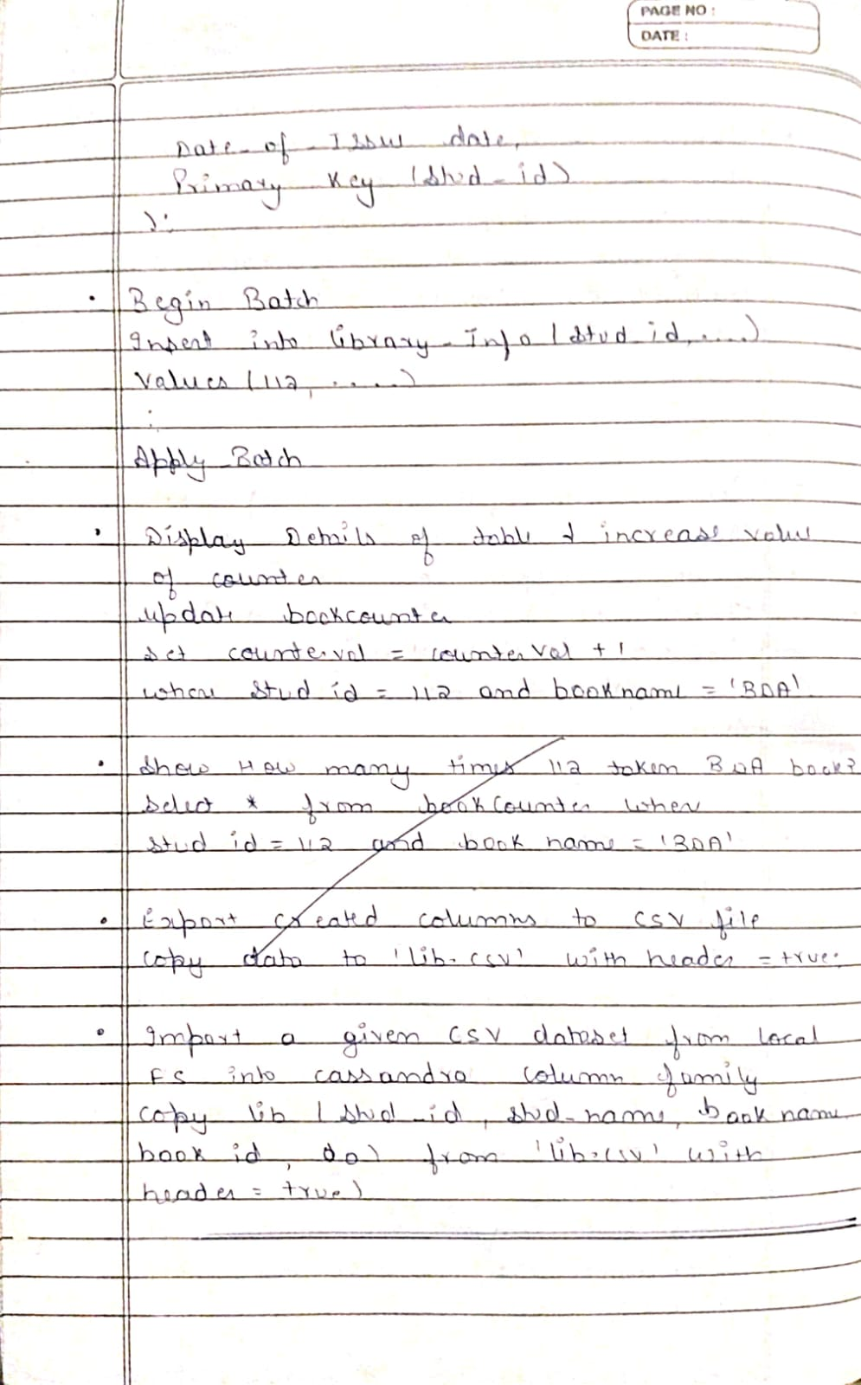

**Lab 5:** Hadoop

Question: From the following link extract the weather data https://github.com/tomwhite/hadoop-book/tree/master/input/ncdc/all Create a Map Reduce program to

a) find average temperature for each year from NCDC data set.

b) find the mean max temperature for every month

Code with Output:

a)

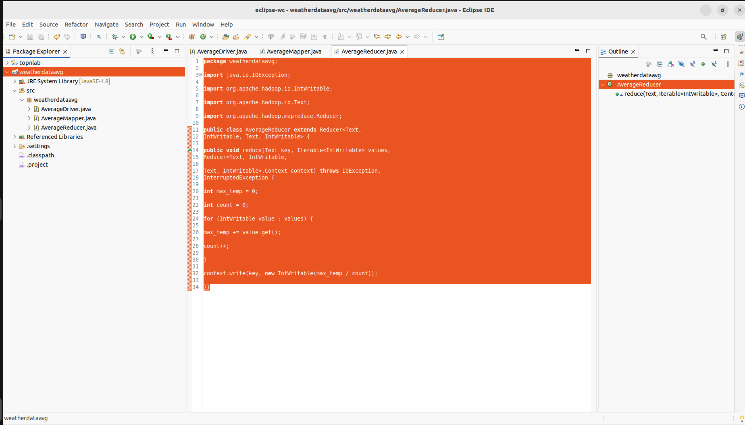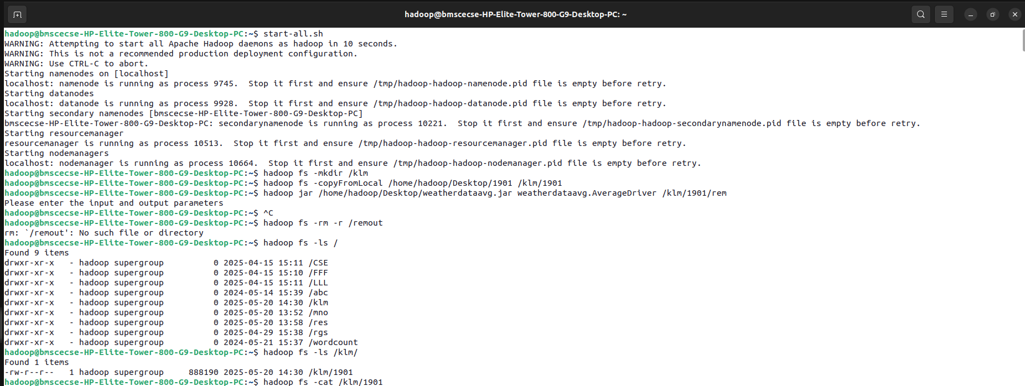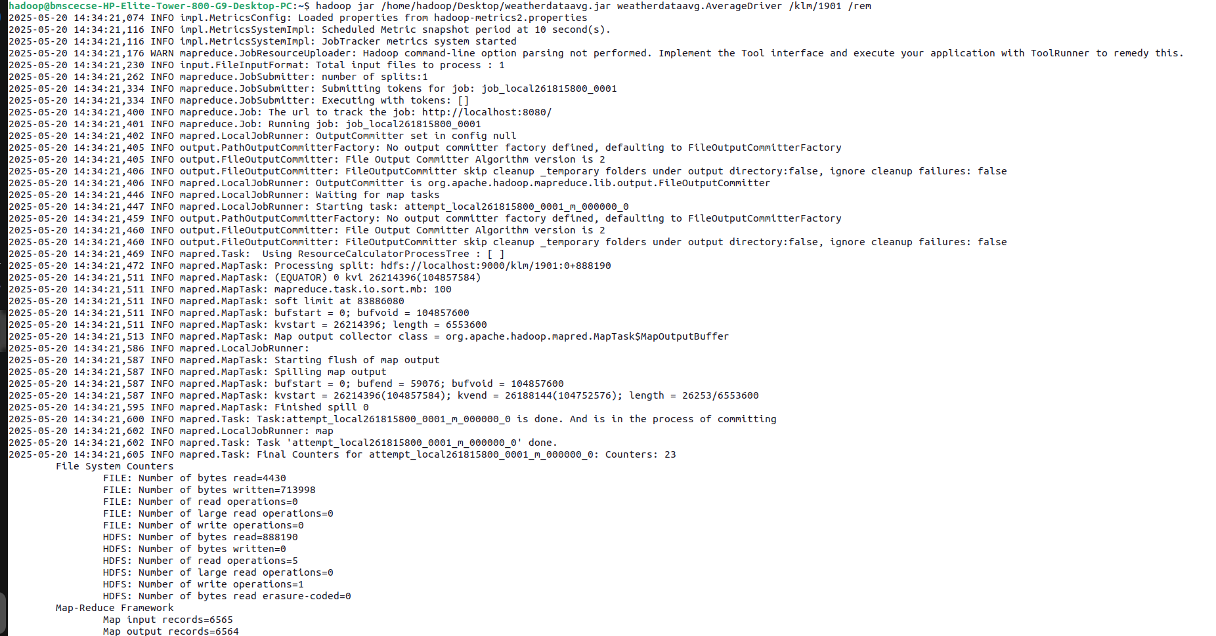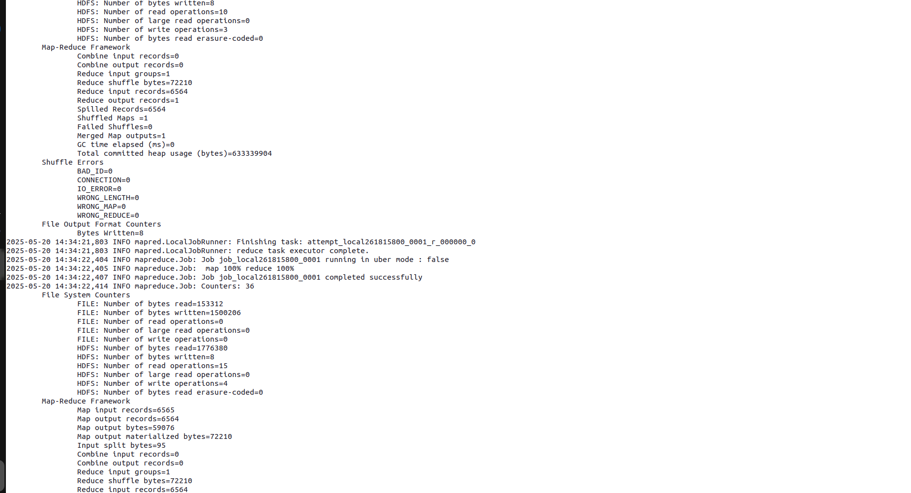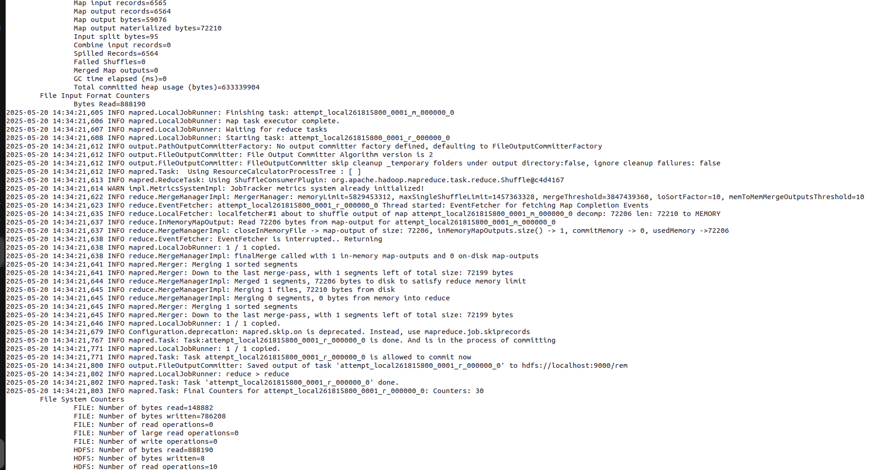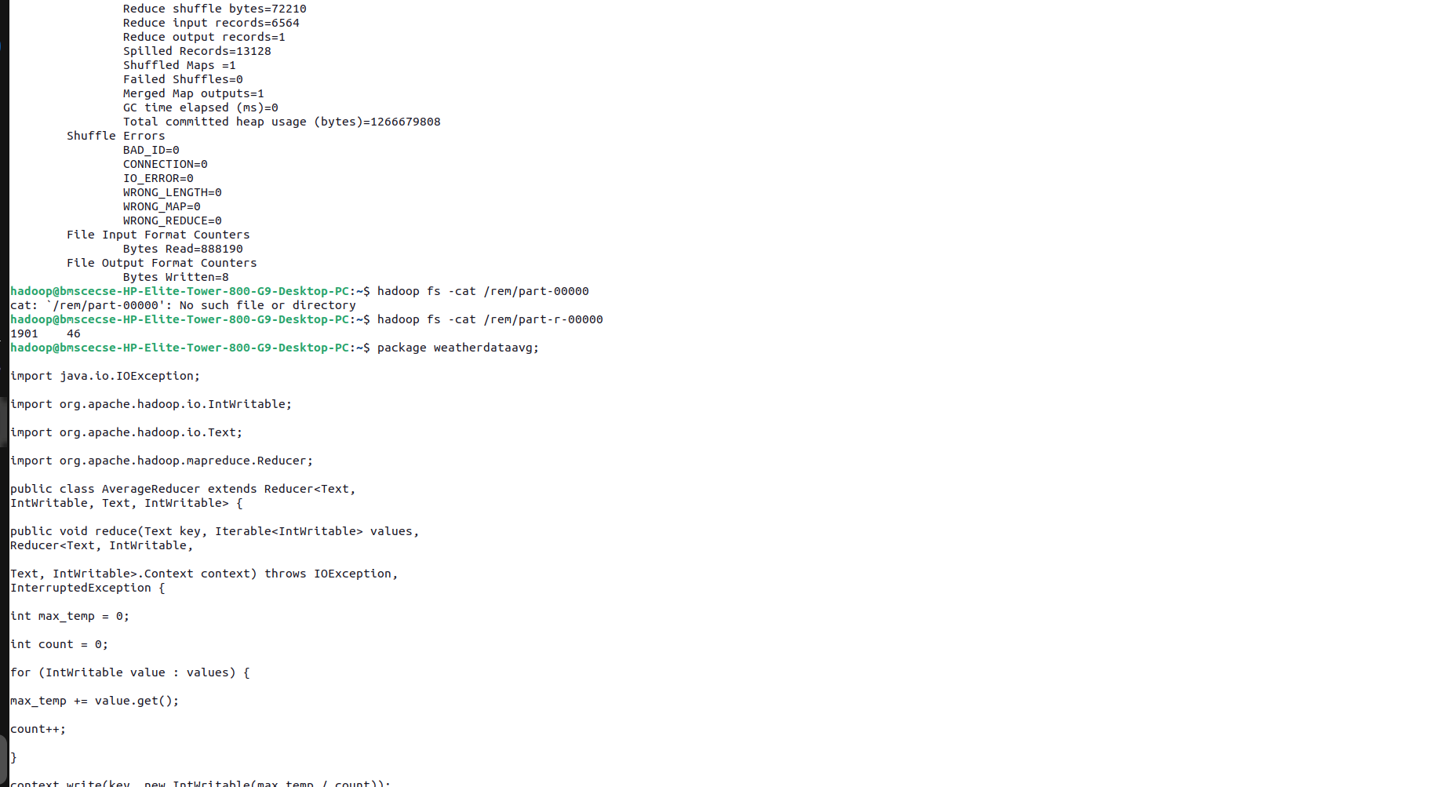

b)

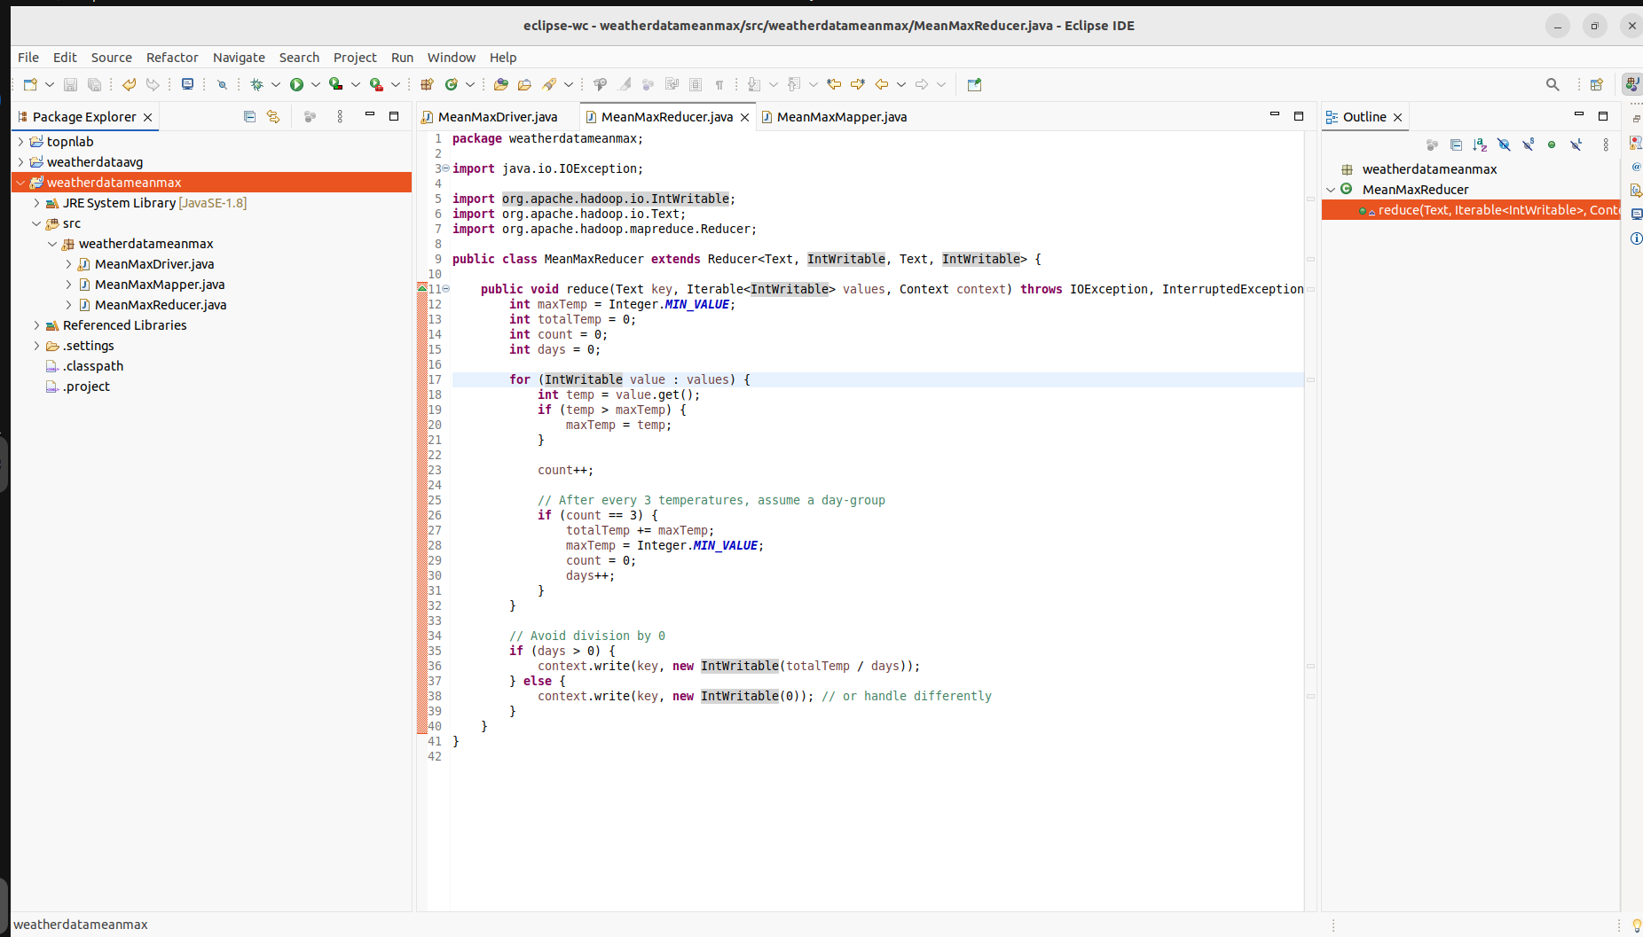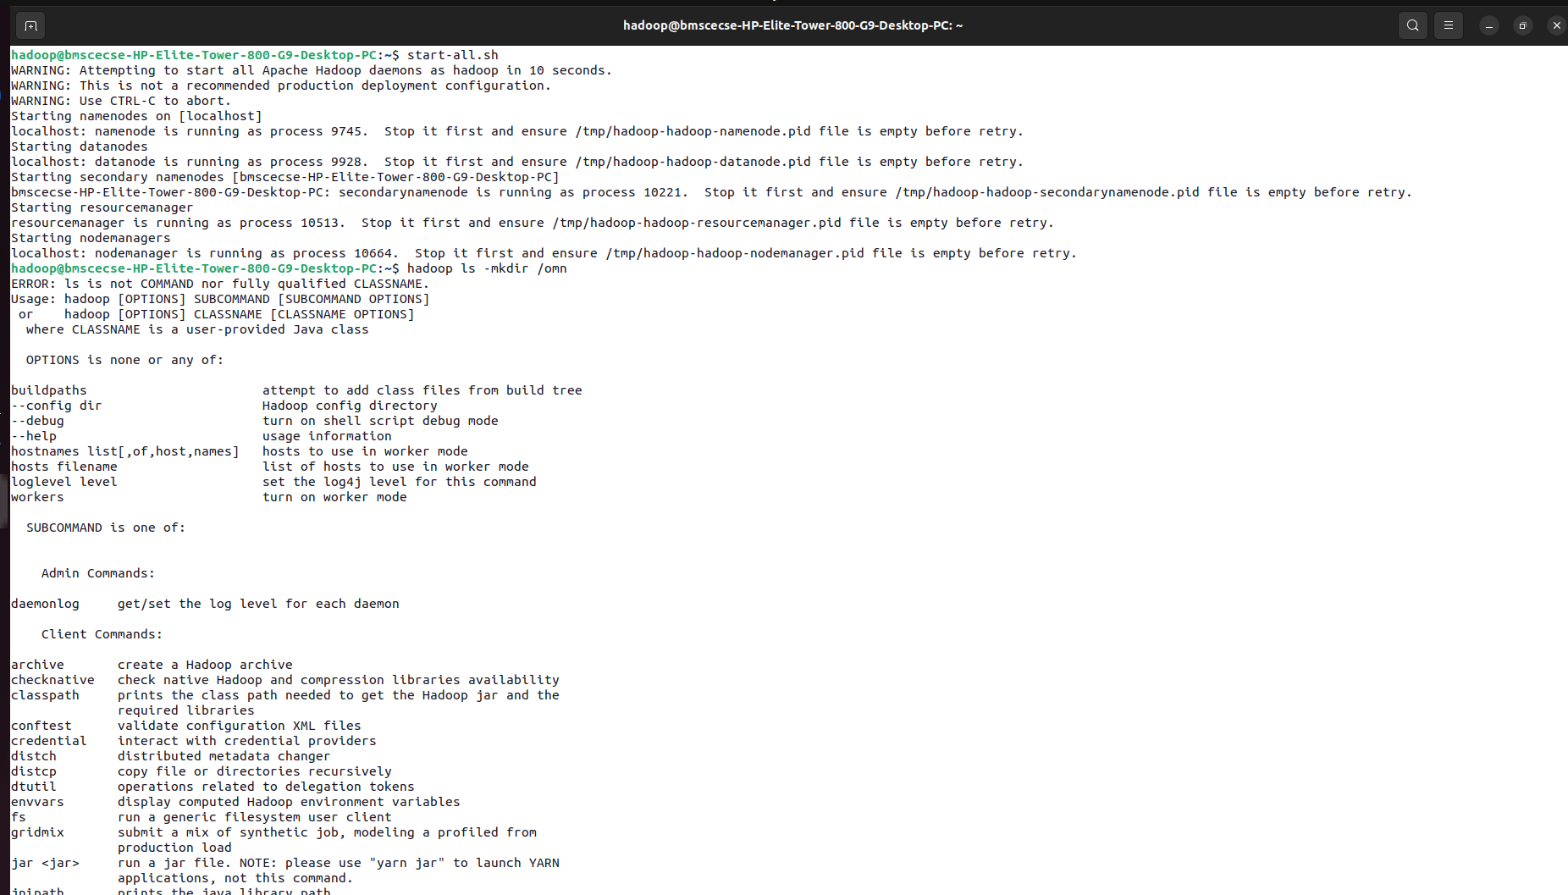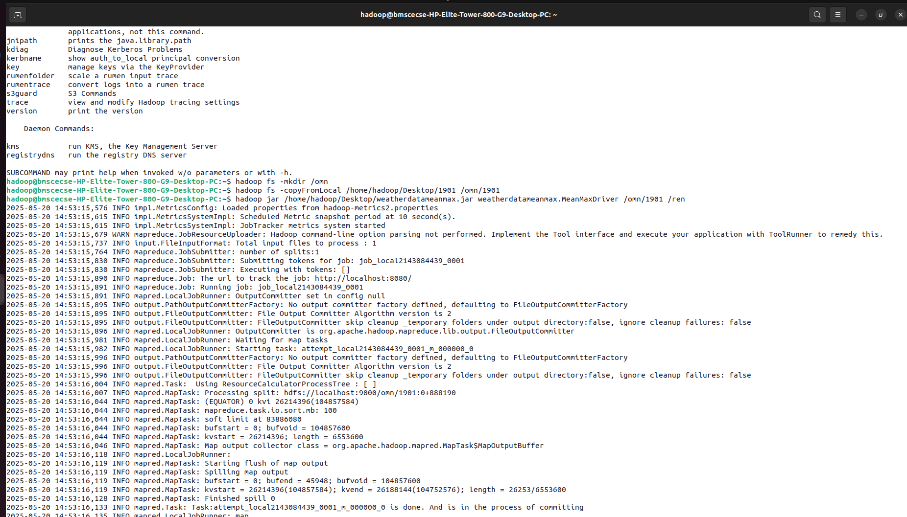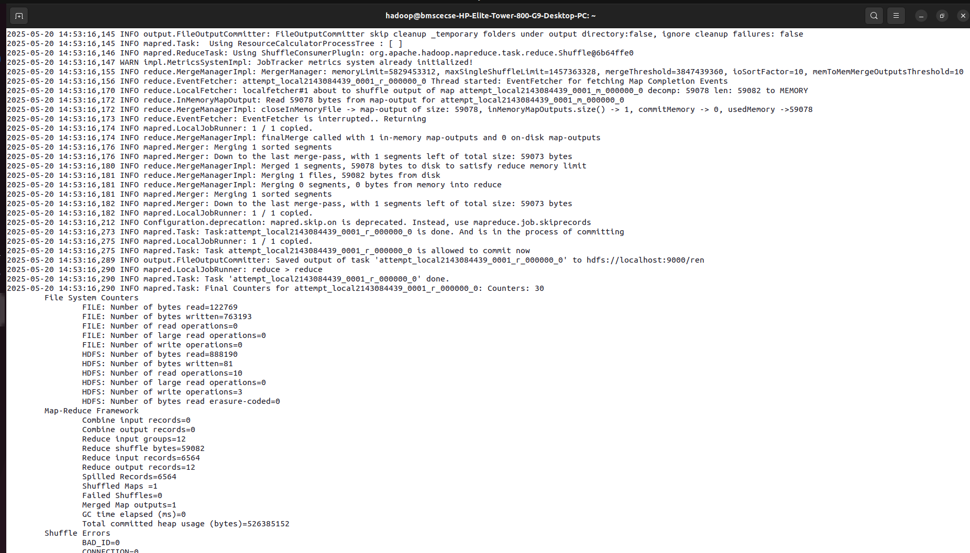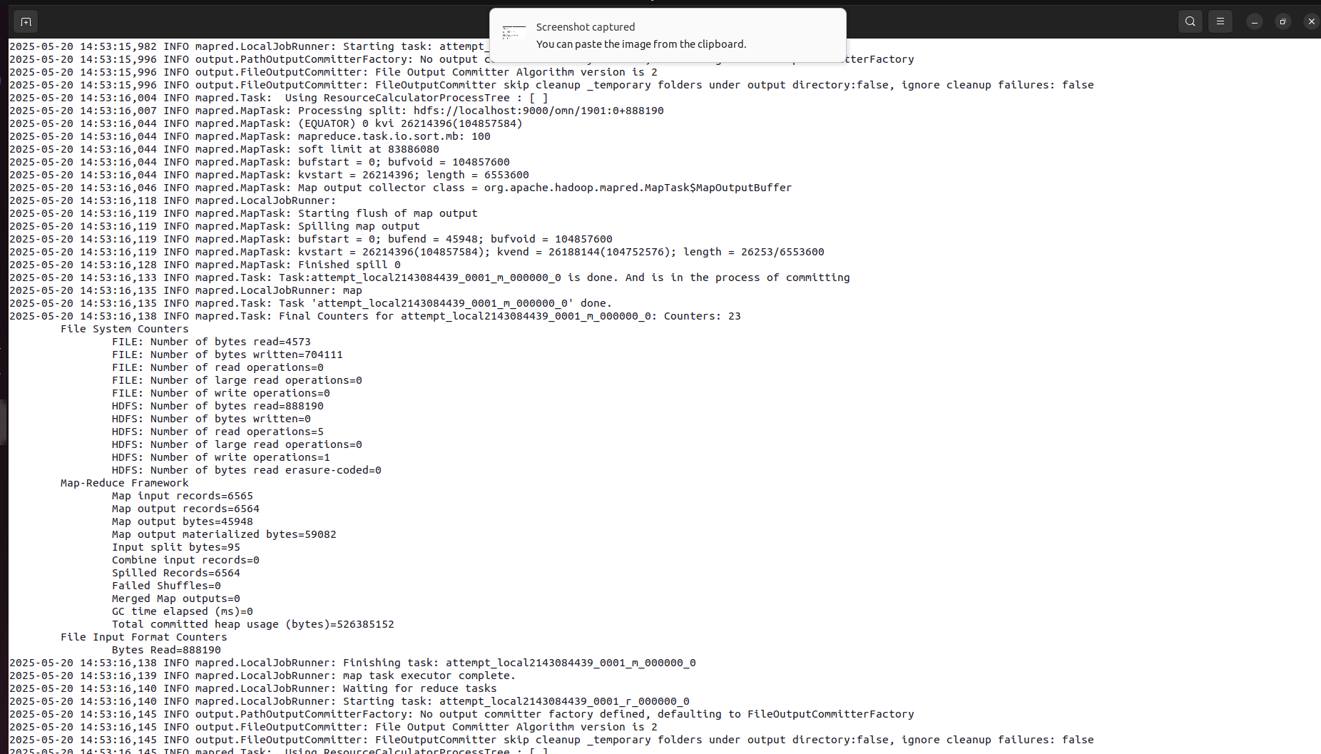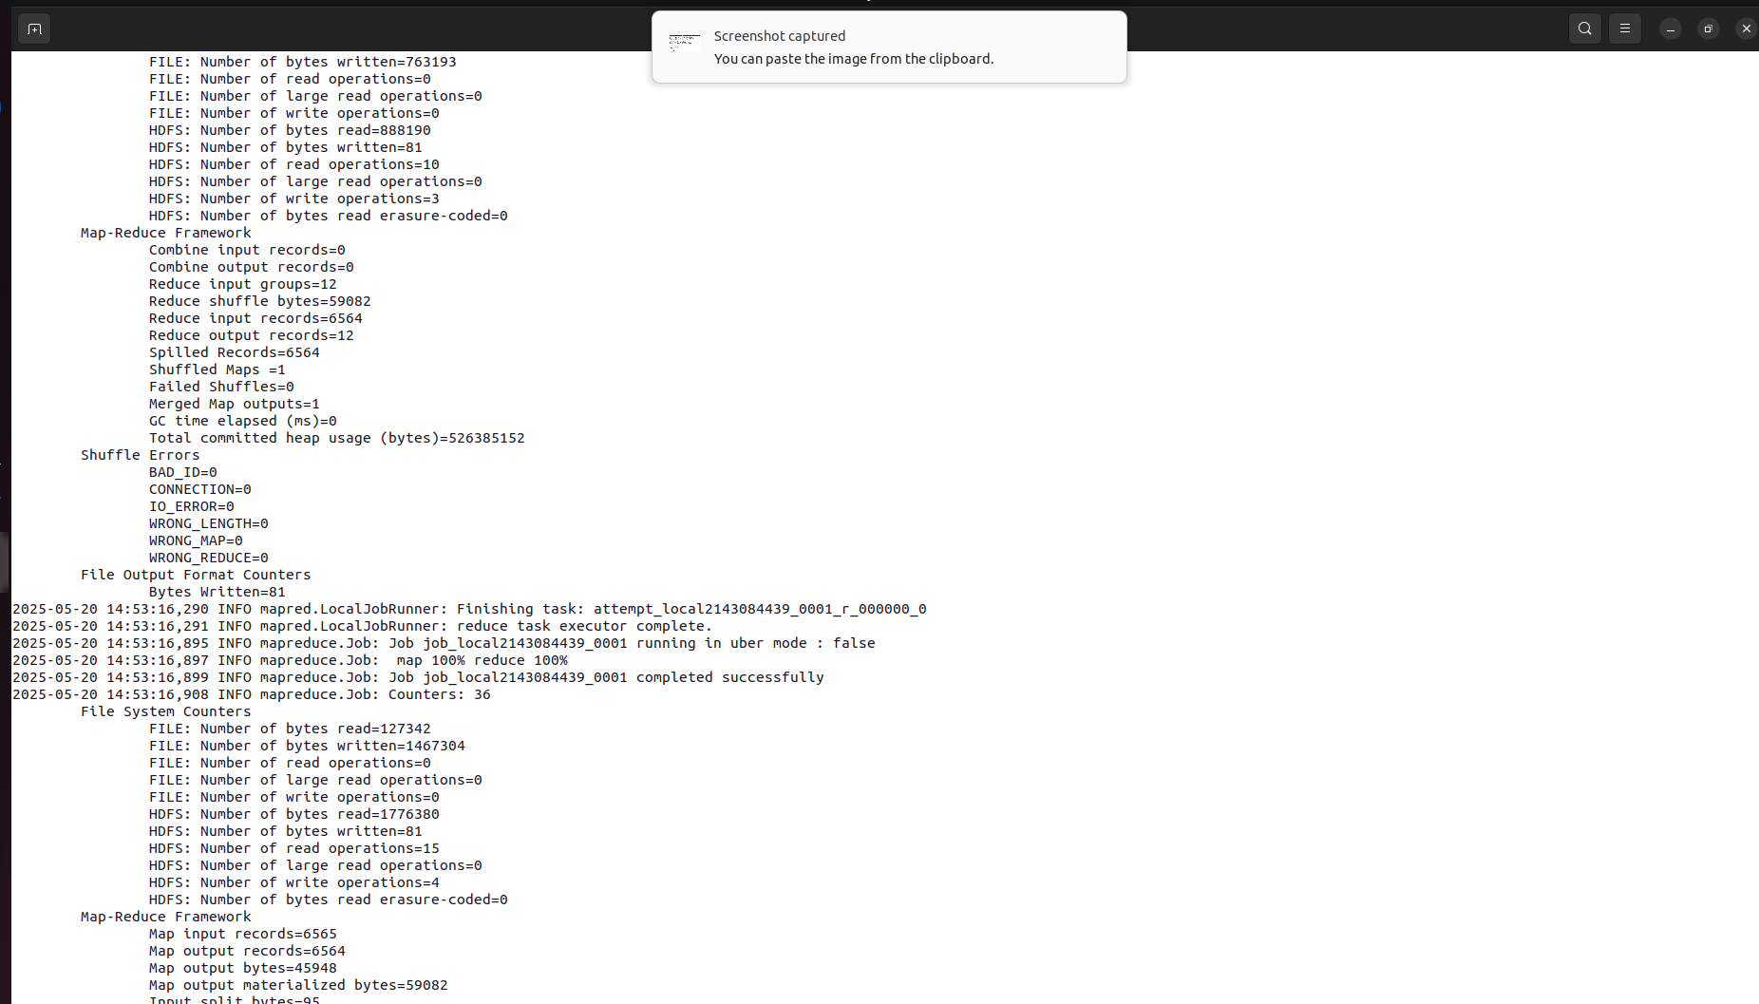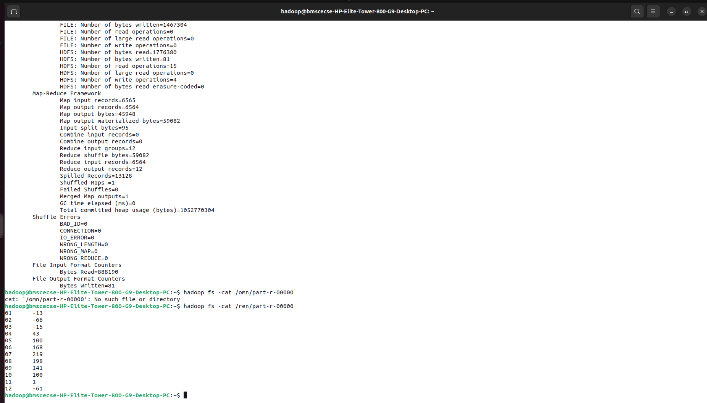

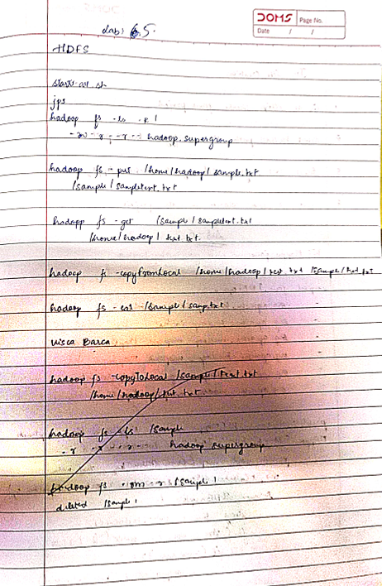

**Lab 6:** Hadoop

Question: Implement Wordcount program on Hadoop framework

Code with Output:

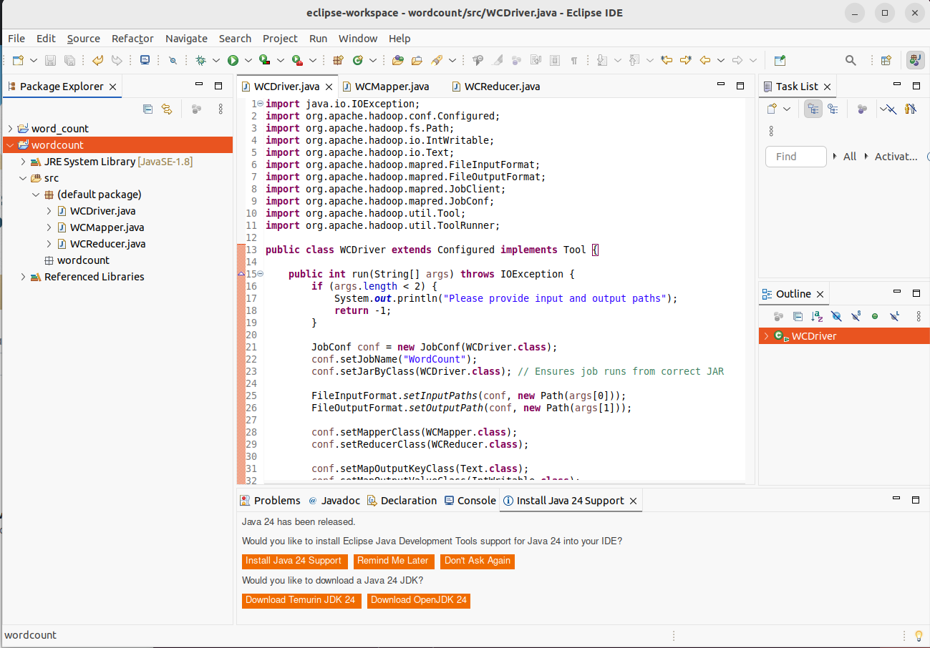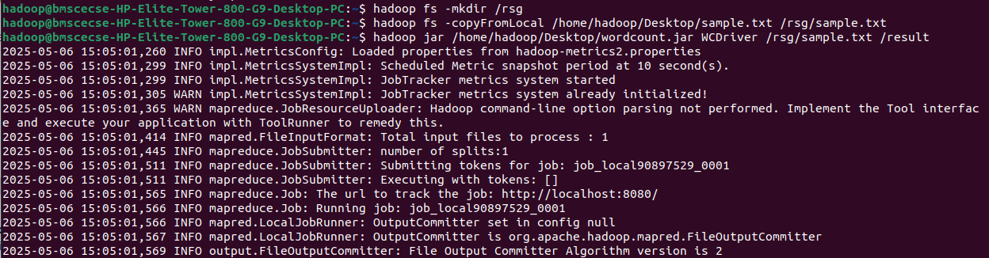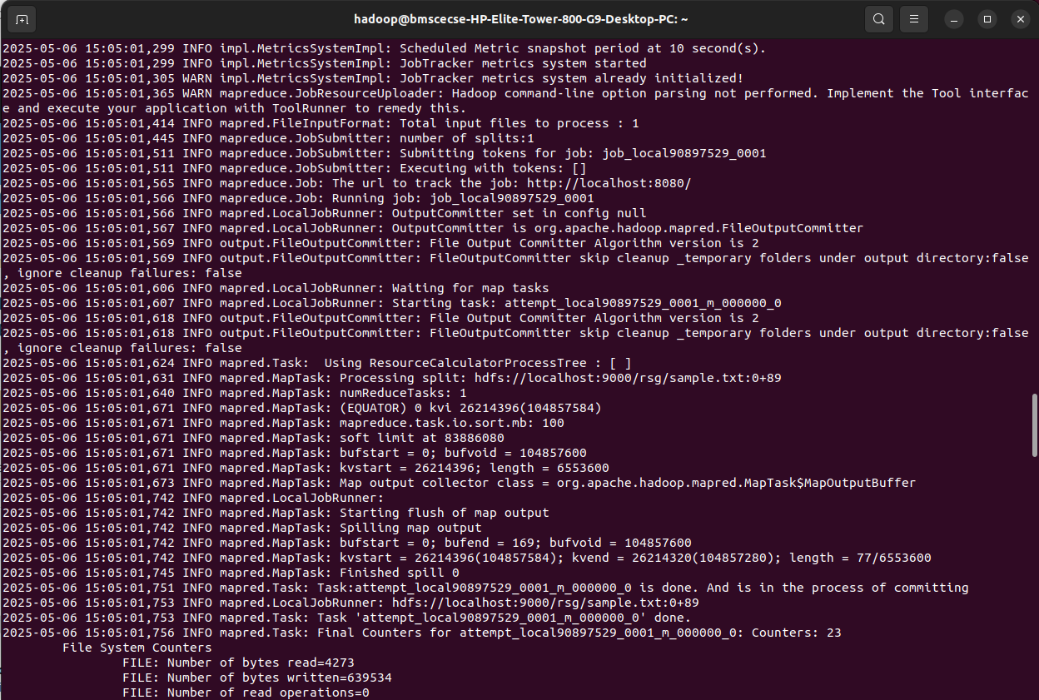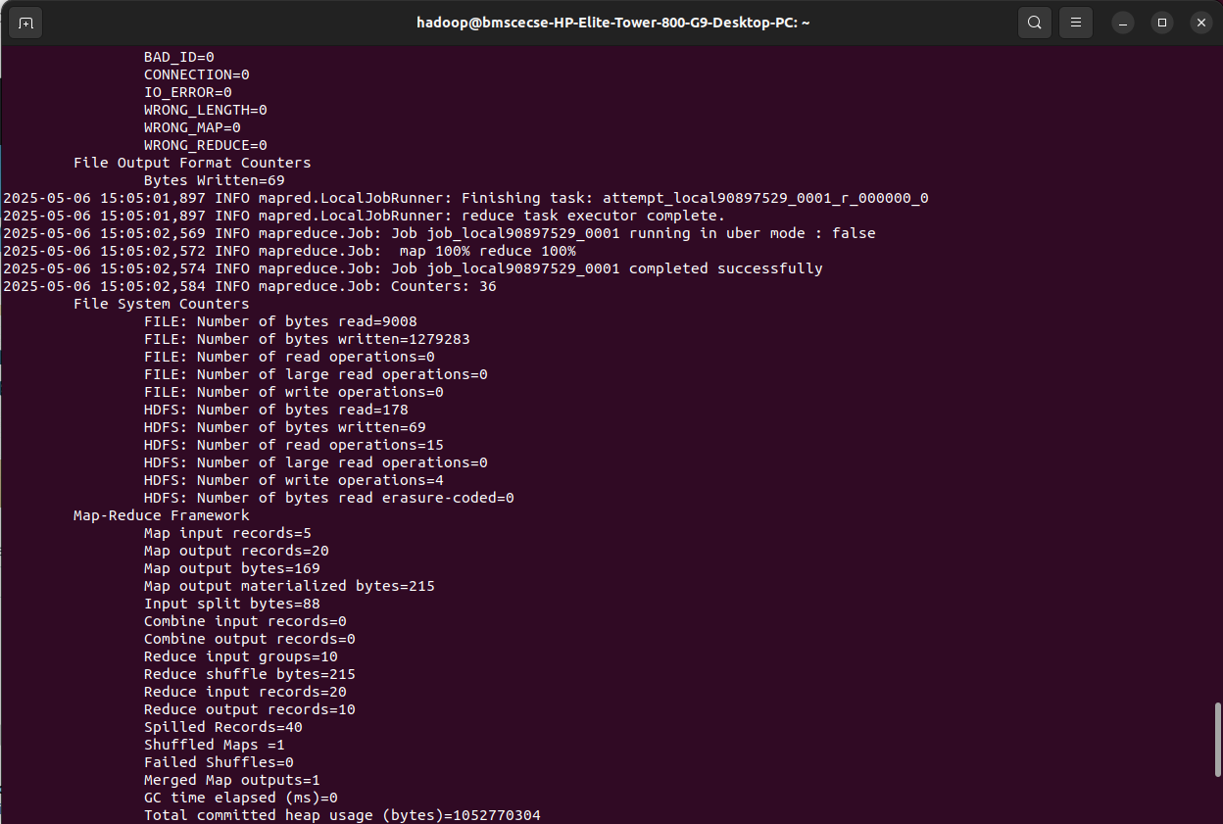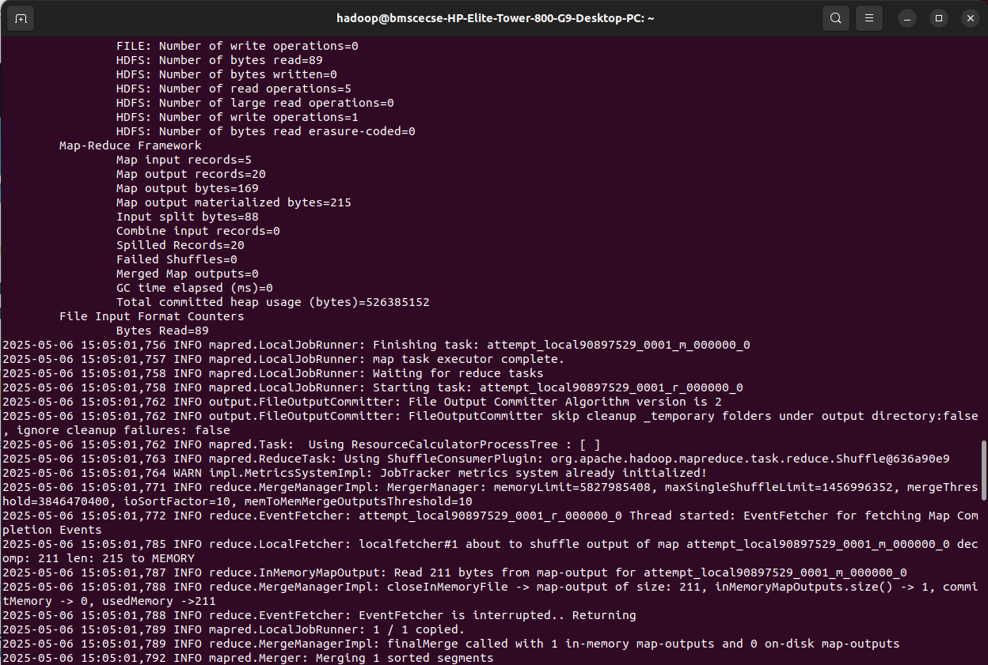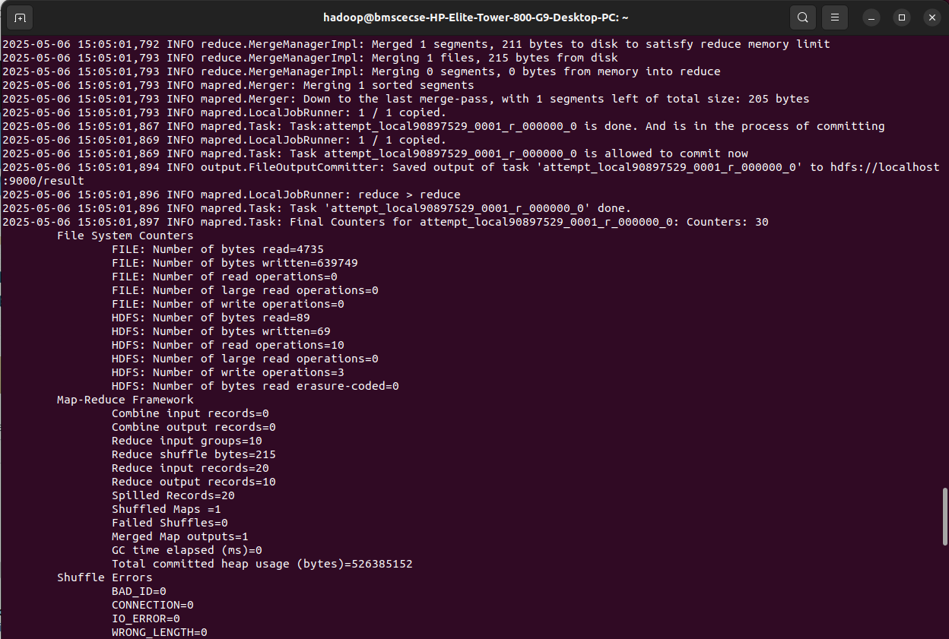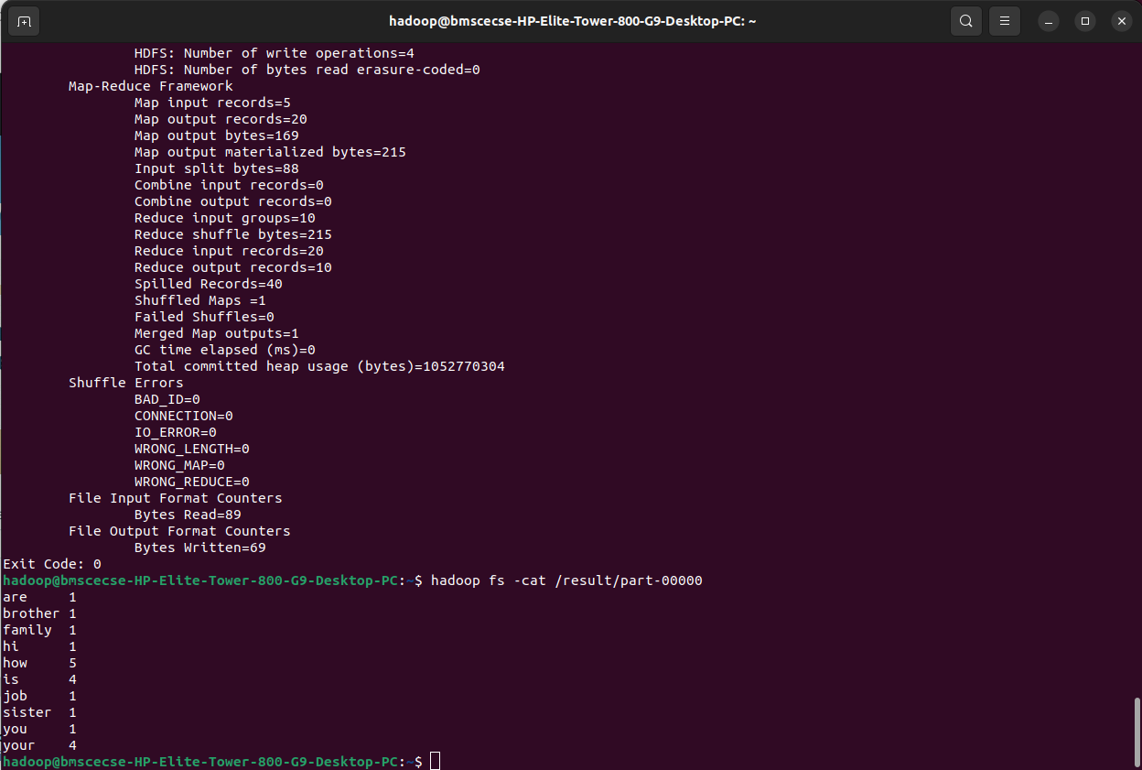

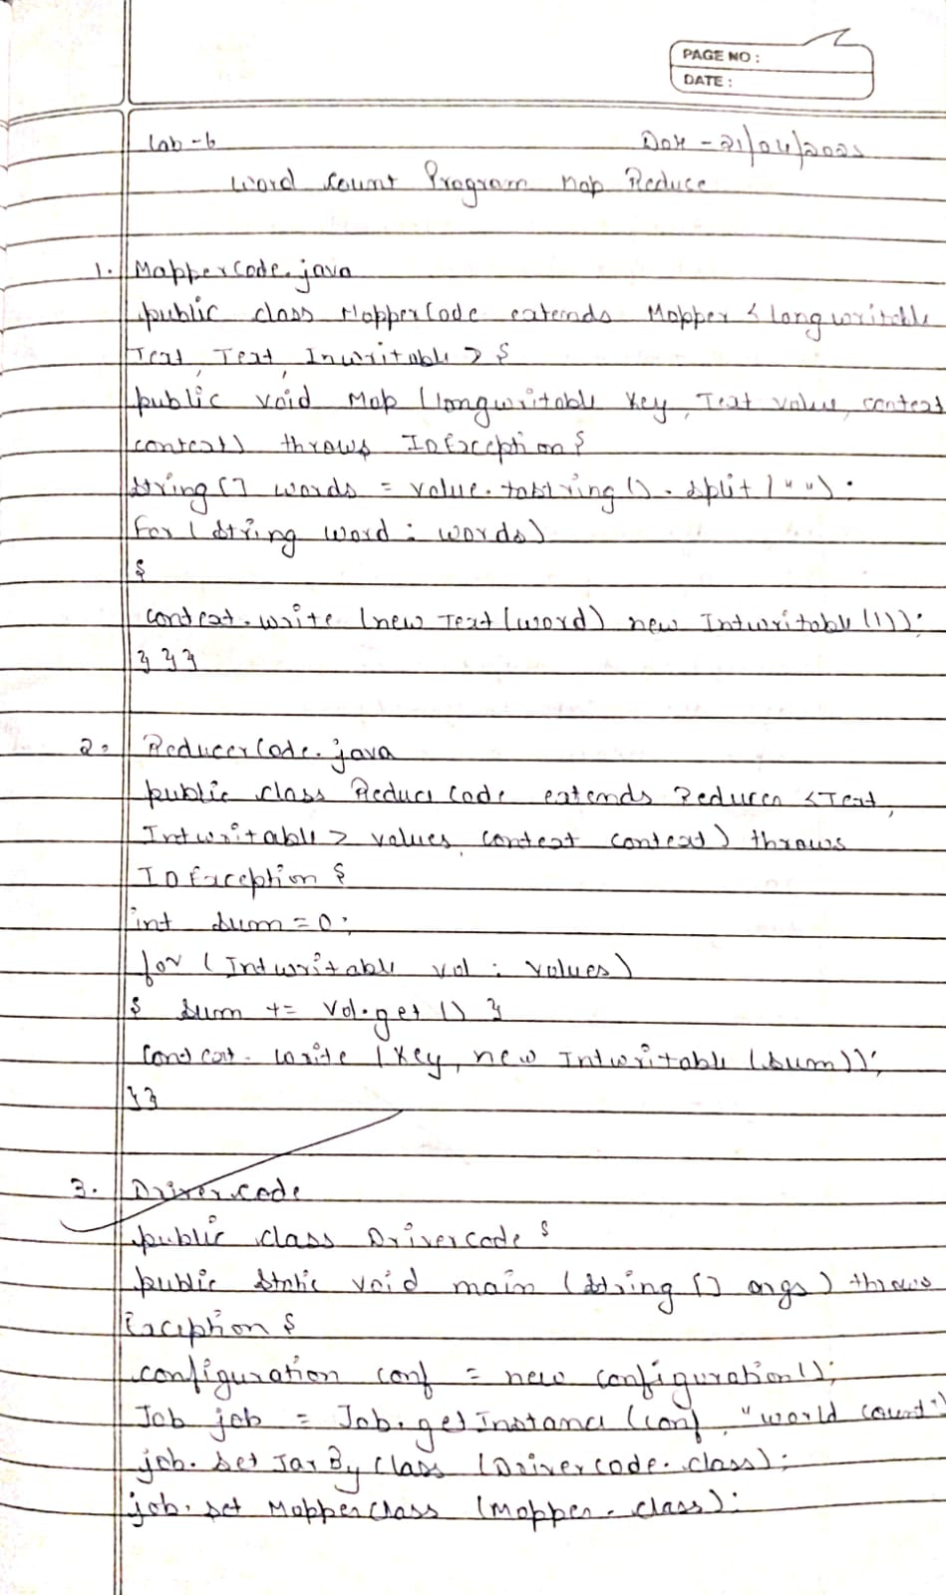

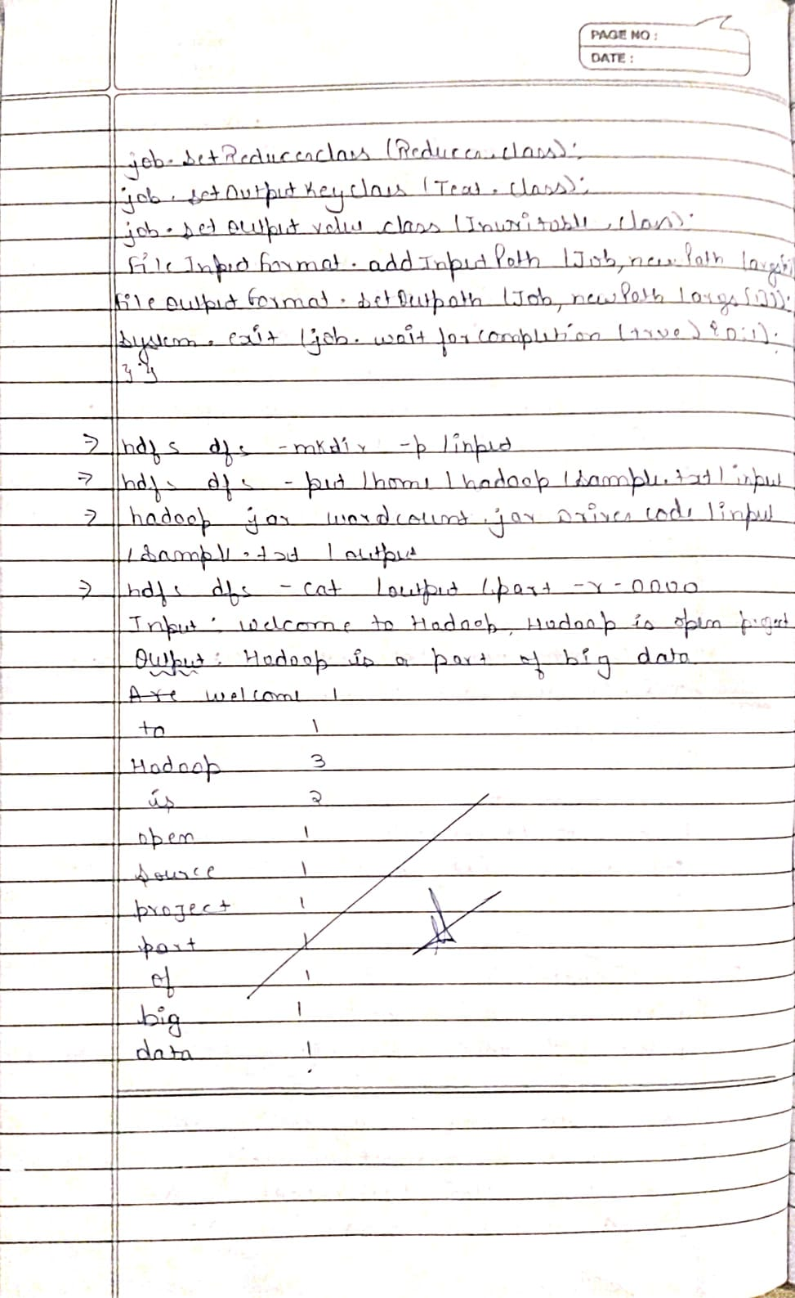

**Lab 7:** Hadoop

Question: For a given Text file, Create a Map Reduce program to sort the content in an alphabetic order listing only top 10 maximum occurrences of words.

Code with Output:

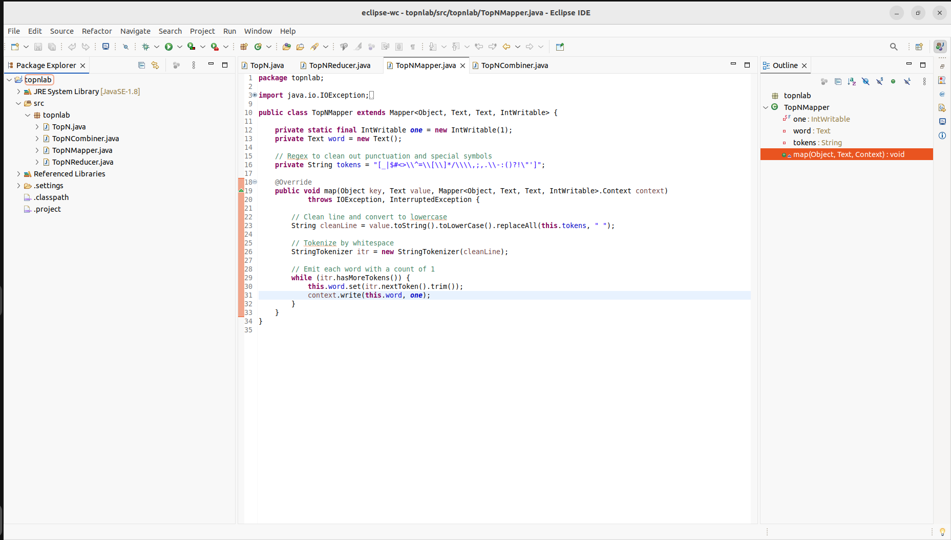

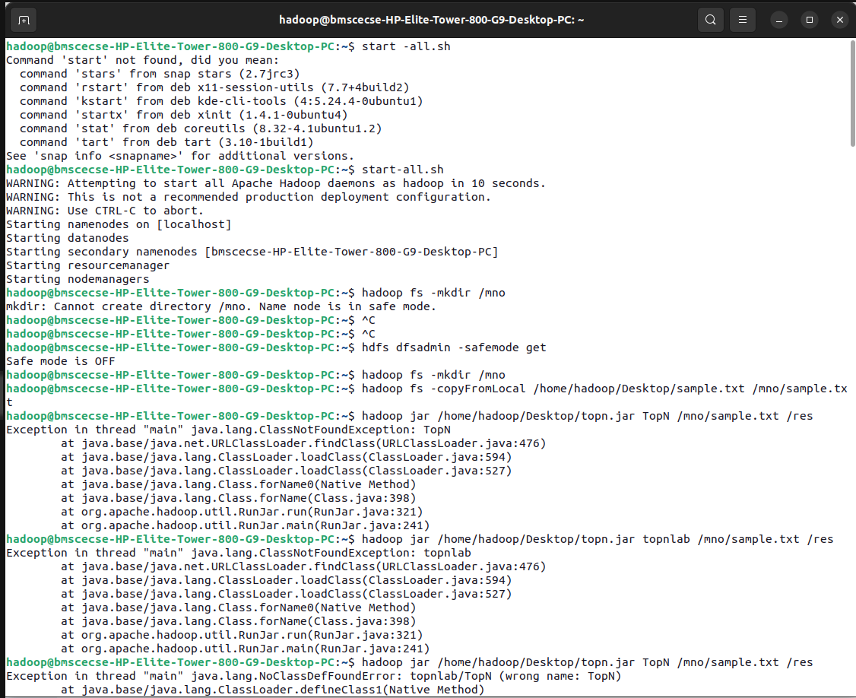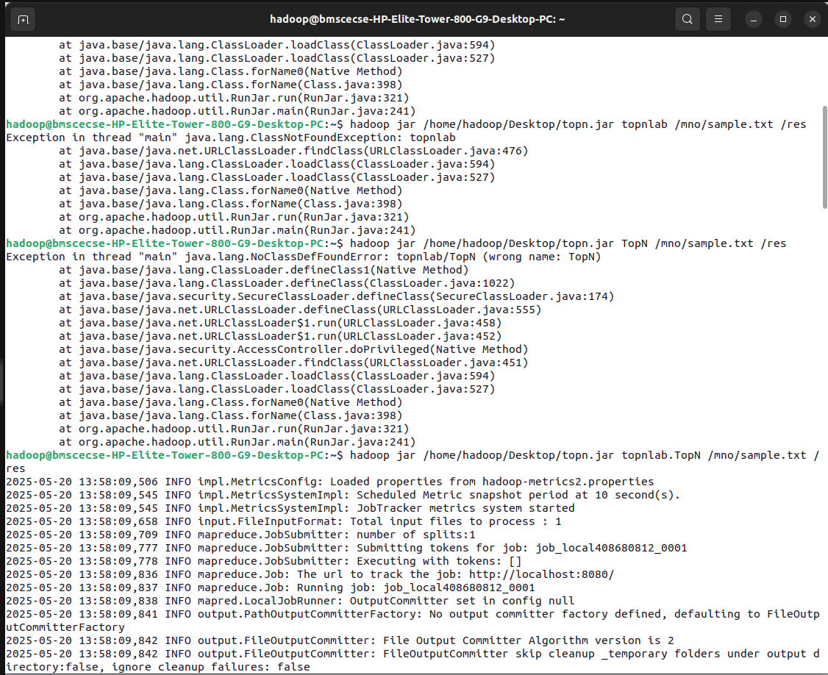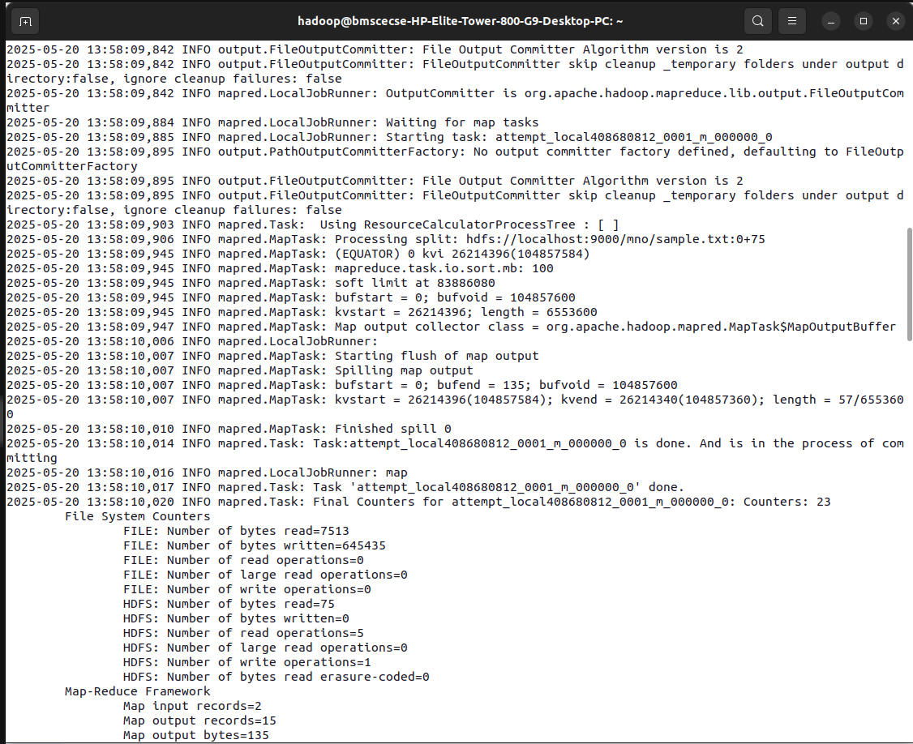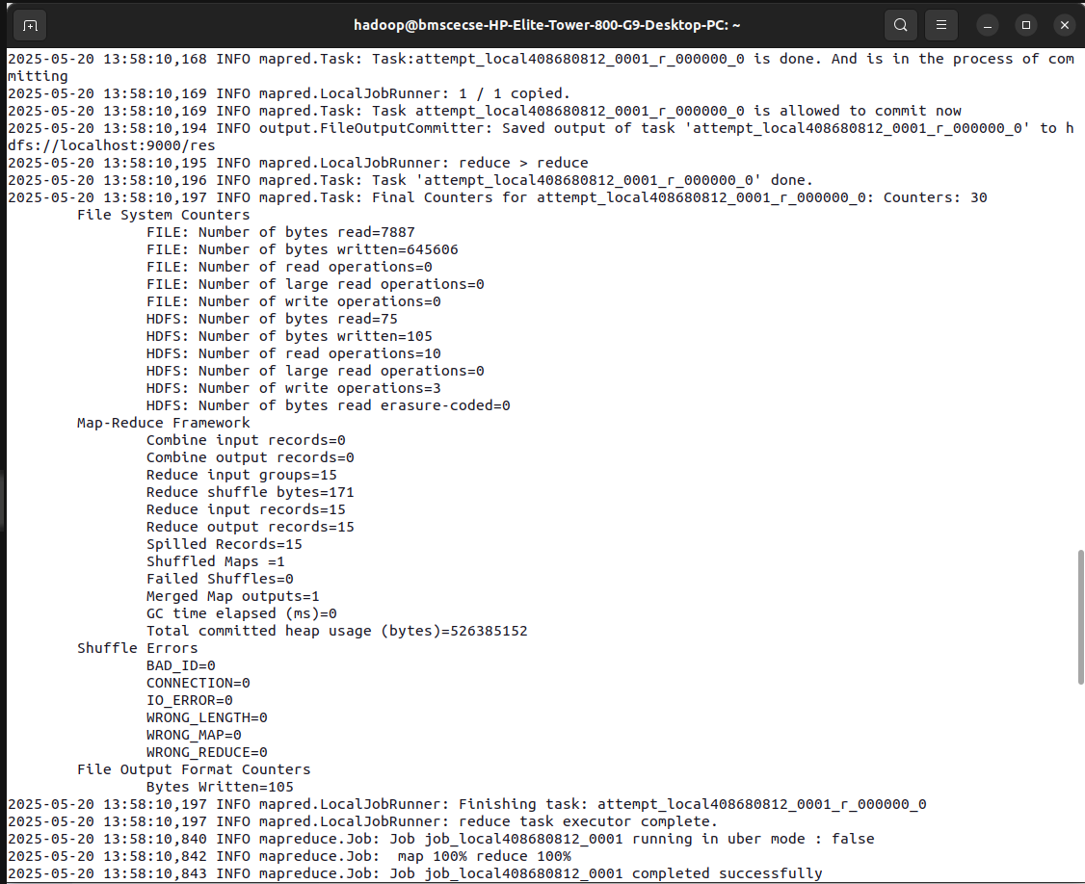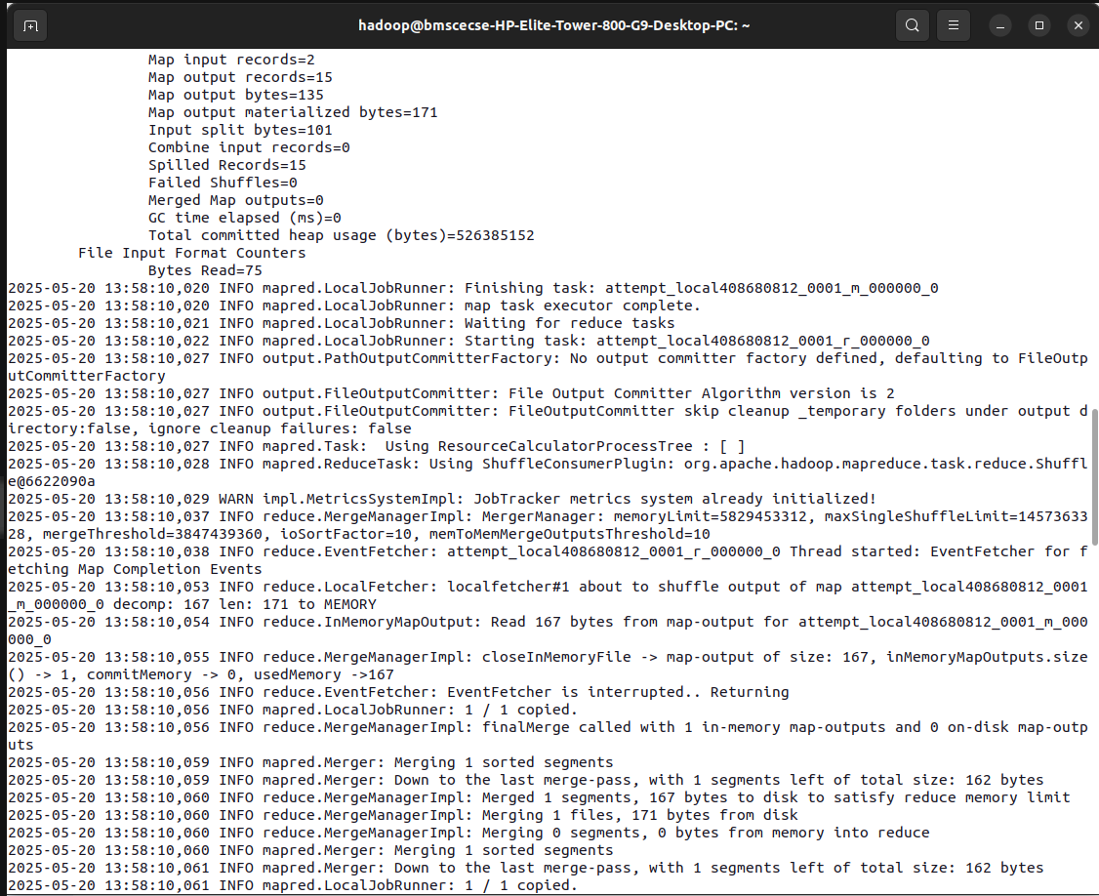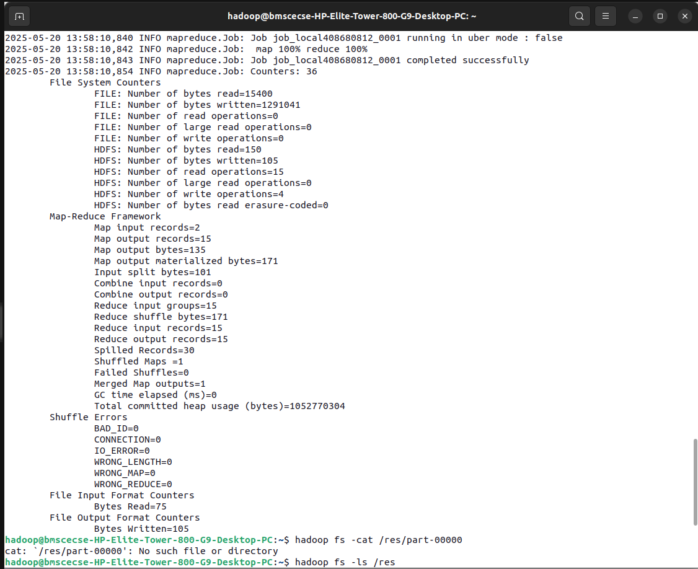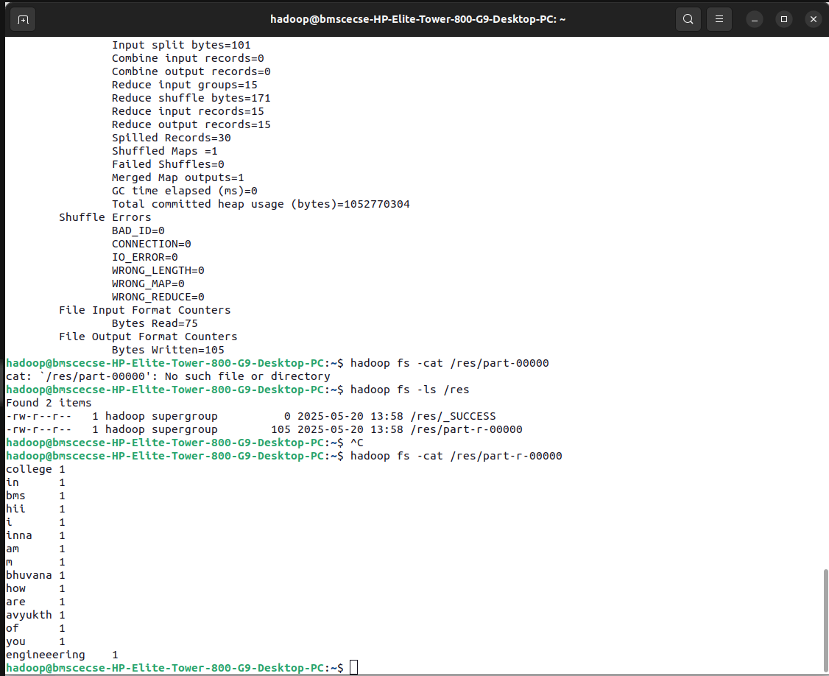

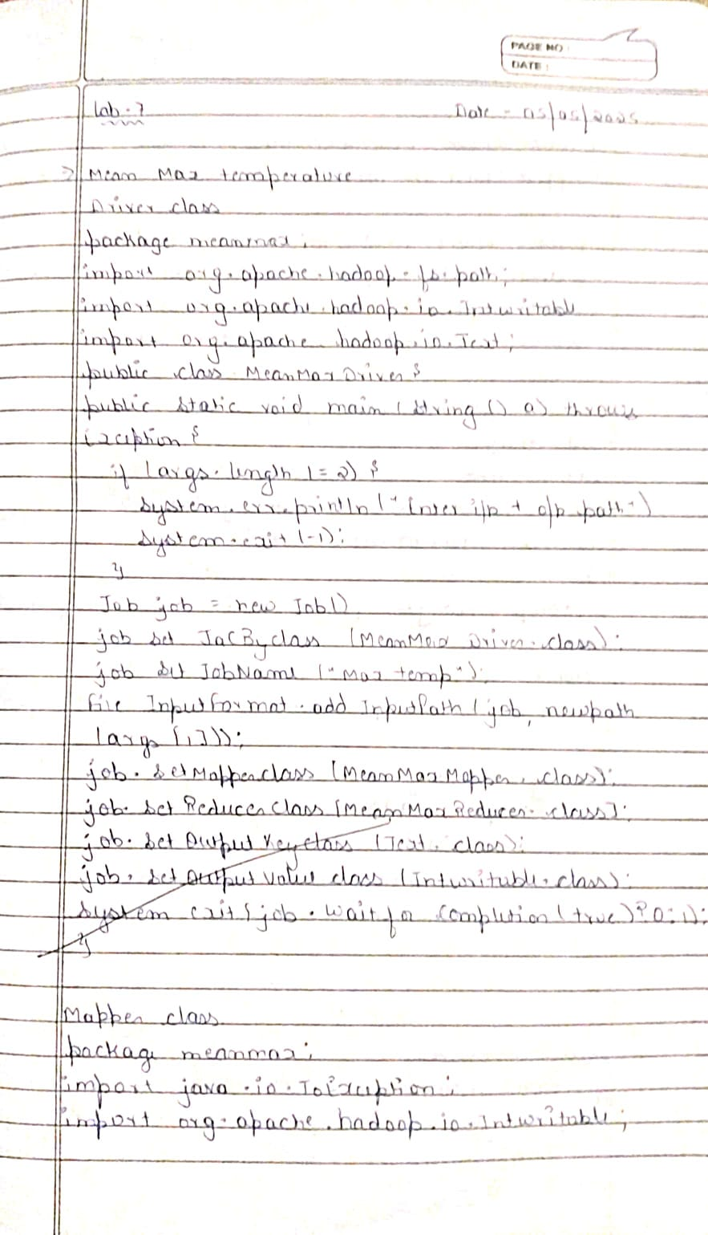

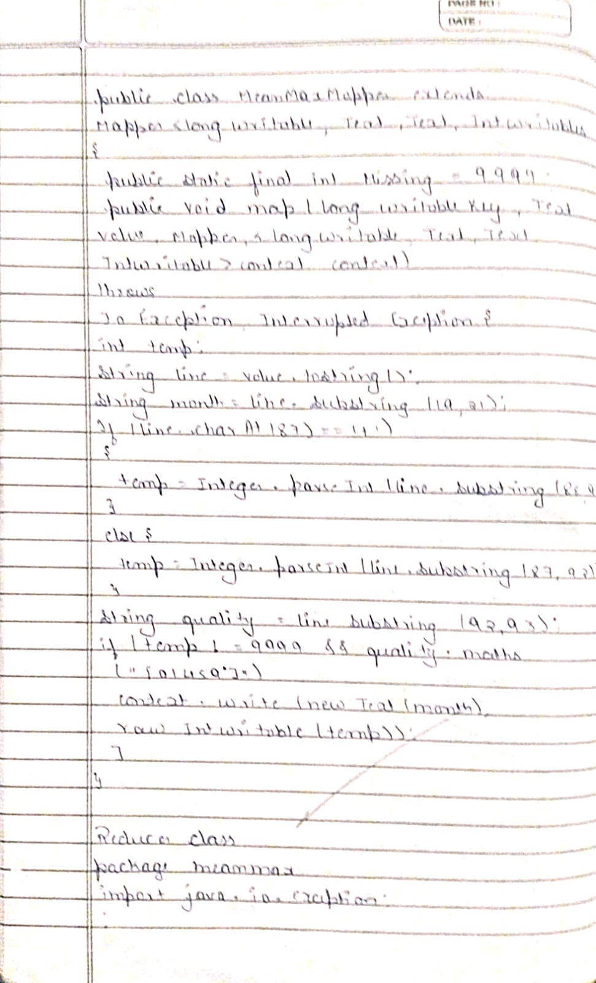

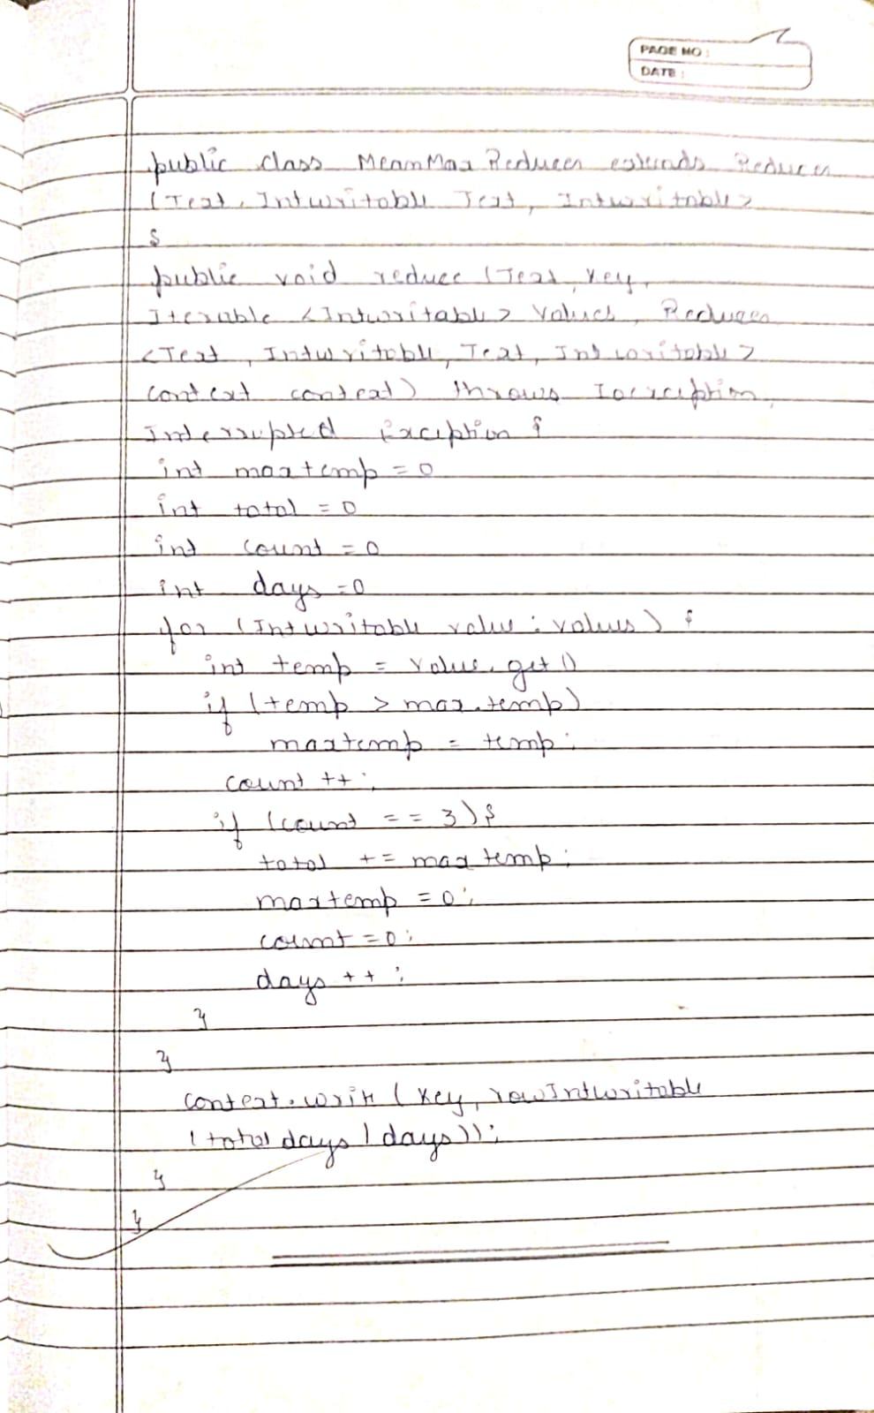

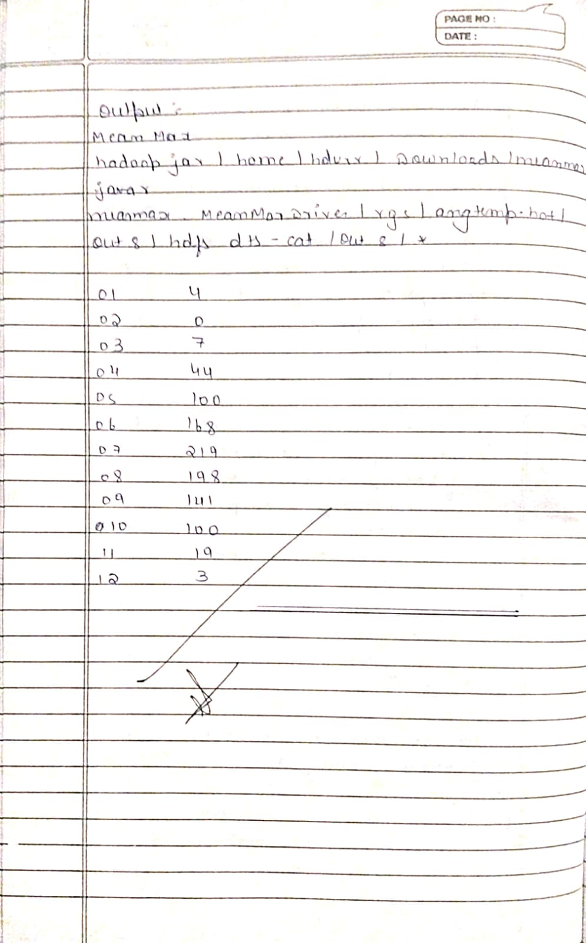

**Lab 8:** Scala

Question: Write a Scala program to print numbers from 1 to 100 using for loop.

Code with Output:

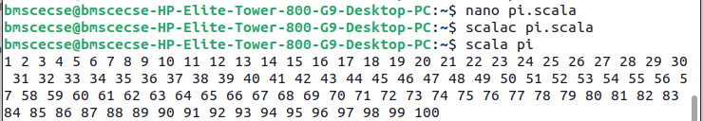

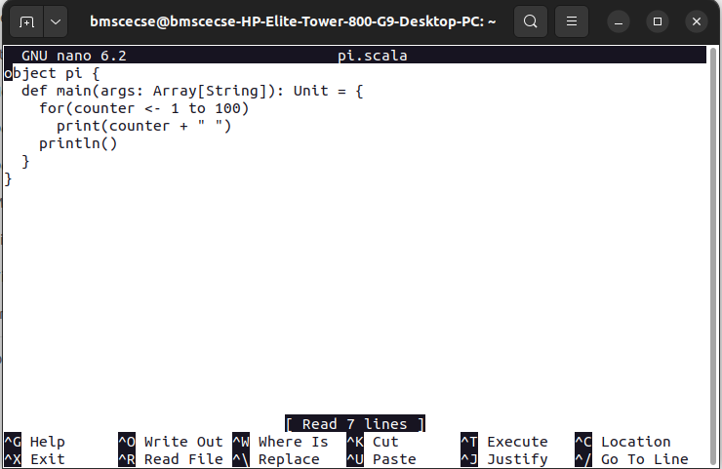

**Lab 9:** Spark

Question: Using RDD and FlatMap count how many times each word appears in a file and write out a list of words whose count is strictly greater than 4 using Spark.

Code with Output:

